Ludmila Ferrari

Ph.D., Spanish and Latin American Studies 2020
Department of Romance Languages and Literatures
University of Michigan, Ann Arbor

Graduate Studies in Cultural Studies MA., Cultural and Visual Studies 2009
Pontificia Universidad Javeriana, Bogotá, Colombia

BFA/ MA., Visual Arts (Licenciatura en Artes Visuales) 2008
Pontificia Universidad Javeriana, Bogotá, Colombia
Universidad Nacional del Arte, Buenos Aires, Argentina

Research

I am interested in studying the material culture that signs experiences of displacement, migration, and groundlessness, especially on the intersections between built environment, violence, and politics in the Americas, working from interdisciplinary archives, including architecture, fine arts, photography, and forensics. My research and artistic practice depart from witnessing the debasement of our inherited political foundations. While, at the same time, facing the pressing question of assembling modes of living together.

I was born in Argentina, a country defined by its profound economic and political crisis. And I grew up in Colombia amidst a civil war supported by the global economy of drugs. Therefore, my work as a Latino Americanist departs from this unstable, militarized ground. Before coming to academia, I worked extensively on community-based art projects. Some of them include Alto Voltaje in Moravia, Medellin (2010) and Tejedores de historias in Ciudad Bolivar, Bogotá (2007-2010), which earned the National Prize for the Arts in 2009. I have continued a close dialogue between my research and artistic practice by developing video installations and urban interventions in Detroit, exploring the relationship between space and race: "Coyote Action" (2017), and "A square foot of Black Bottom" (2020). More recently, I have been working with photography, race and ethnography in a study of the archive of the Atlas Linguístico Etnográfico de Colombia (ALEC).
My dissertation, Degrounding Latin America: Architecture, Violence, Community, underscores the importance and expands the understanding of architecture in the field of Latin American Studies. A historically privileged metaphor for social renewal and progress, architecture is a cultural text through which I read the foundational violence of capitalism: from ongoing projects of settler-colonialism to the landscapes of narco-accumulation. By considering three foundational projects, I explore the relationship between architecture and power in the construction and decomposition of the nation as common ground: the institution and destruction of the Jesuit “reductions” in colonial Paraguay (1607-1767); the construction of Brasilia in 1956; and Peace Process in Colombia (2002-2018) including La Escombrera (2001-2015), the largest “urban mass grave” in the Americas (1999-), a landfill of rubble (escombro) from Medellín's urban renewal that conceals the bodies of 300 victims of State violence.

I am currently preparing the manuscript for the art book: Escombrera: el peso de la Paz.

Teaching

In addition to my research, I have extensive experience teaching, including the complete Elementary Language Program sequence of Spanish language using the communicative approach, and more specialized courses on cultural studies, art, architecture, literature, and film. My teaching interests range from non-canonic architecture and spaces of violence to artists and collectives whose work deals with those foundations. From the Guarani woodworkers that carved indigenous faces inside Jesuit churches to the "Instant Murals" of the Chicano art collective, ASCO. My classrooms become forums where we examine structures and explore strategies of resistance and transformation. As a postdoctoral fellow at the University of Michigan and previously as a Visiting Instructor at Earlham College, I have developed teaching strategies to expose students to the Latin American archive, including its diaspora to the U.S. My classes combine research skills with a hands-on approach, a theoretical-practical method that empowers students to create, and not only acquire, knowledge.
Our students live in postmodern, global times with different values than their parents: creative thinking, personalized politics, environmentalism, green consciousness and solidarity, social networking, friendship, and community bounding. To inspire learning, we must meet students in a shared space of knowledge, between their experiences and other ways of thinking and being.

Selected publications
En la Grieta: Práctica Artística en Comunidad, Editorial Javeriana, Bogotá, 2016.
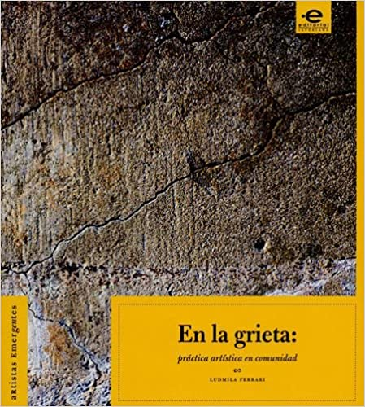

“Sin domicilio: Fotografía, verdad y an-archía en el Pacífico Colombiano”. Afrohispanic Review, Special Issue. Vol XXXIX (Forthcoming November 2022)

“Un instante indómito: arquitectura, soberanía y diferancia en Brasília”. Latin American and Latinx Visual Culture Journal. University of California Press (Forthcoming December 2022)

Voices of the Grassroots: Histories of Housing and Land Inequality in Detroit. Detroit Equity Action Lab (DEAL), Law School, Wayne State University.

“Un escombro enamorado: apuntes para una sensibilidad forense expandida”. 2021
Escrituras de la catástrofe: bio-necropolítica en América Latina. Eds. Dr. Alina Peña, Universidad de Guadalajara, Mexico

“Différance: A Breathless Opening”. Special dossier on the seminars of Jacques Derrida. Política Común, number 13, n.p., https://quod.lib.umich.edu/p/pc/

“Written on Glass: A Photo-Essay on Detroit 67”. Failed Architecture, n.p., 2018 https://failedarchitecture.com/photo-essay-written-on-glass-detroit-67/

“Colored Photographs: A Question on Infrastructure”. 2017
Afrohispanic Review, Special Issue. Vol. XXXVI, number.1, 213-30

“Un epígrafe cimarrón para la libertad: Monumentalización, silencio 2016
y repetición en el archivo de San Basilio de Palenque”. Revista Iberoamericana, Special Issue. LXXXII, number. 255, 597-618

