Accessible Web Pages & Media

For more information and links to resources, please visit https://www.amherst.edu/go/ThinkAccessible

Overall goal: to make web sites more accessible to more users, including users with the following disabilities:
- Visual (blindness, low vision, color blindness)
- Auditory (deaf, hard of hearing)
- Motor (unable to use mouse and/or keyboard)
- Cognitive (learning disabilities, attention disorders, autism)

The Five Elements of Digital Accessibility

1: Searchable, Computer-Readable Text
- Can you select all the text on the page with your mouse, or copy and paste it? If not, it’s saved as an image, which is not accessible.

2: Proper Use of Headings and Structural Elements
- Users of assistive technology rely on heading levels to navigate documents and web pages.
- In the Amherst CMS, use the Format menu (which says “Paragraph” by default) to apply a heading to selected text.
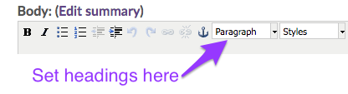
- Use the text editor options to create bulleted lists and indent items, instead of manual formatting (ie typing tab or space).
- Don’t use bold/italic formatting to convey meaning (ie “important dates are in bold”)- screen readers don’t convey this information.
- Don’t use tables for layout (using them for data is OK).

3: Images and Charts have Alternative Text
- Does an image represent or contain relevant information to your audience? Make sure to add a description for people who cannot see it.
- In the Amherst CMS, add alternate text when inserting an image:
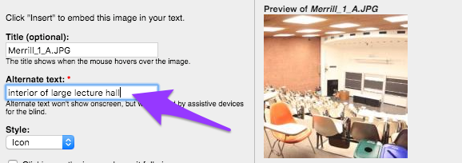
- Write your alt-text to be concise but specific. What relevant information does the image contain? Instead of “Biddy Martin”, say “Biddy Martin speaking at a lectern in Johnson Chapel”.
- Don’t use an image that contains text! It can’t be read by screen readers. Put the text, as text, on the page instead.
- For graphs or charts:
  - A description that includes the relevant information or main “take away” from the chart may be sufficient.
  - A properly formatted data table can also serve as a replacement or supplement.

4. Link Text is Descriptive, Helpful, and Unique
- Screen-reader users often use a keyboard shortcut to list all the links on a page. In such a list, the links have no surrounding text.
- Instead of “Click here to see our President’s Welcome,” put “See our President’s Welcome.”
- Descriptive link names also make pages more scannable for sighted users.
- No visible URL’s, please- make words on your page into link.

5. Proper Use of Color & Adequate Contrast
- Don’t use color to convey meaning.
- Make sure font sizes and colors are large and easily readable against the background.

Built-In Accessibility Checker
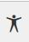
- The Amherst website has a built-in accessibility checker that will find issues with headings and tables. To run it, click the icon in the toolbar that looks like this:
- More info here on using the accessibility checker.

Files and Attachments
- All of the above concepts apply to documents as well!
- Special considerations for PDF’s:
  - Make sure text is searchable/selectable. Image-only PDF’s are not accessible.
  - PDF’s in wide distribution should ideally be run through Acrobat’s Accessibility Checker.
  - Complicated PDF’s or PDF forms in wide distribution may need professional remediation.

Forms
- PDF forms are very difficult to make fully accessible.
- Drupal CMS webforms, Google Forms, and Qualtrics are all accessible options.
- See our Accessible Forms page for more information.

Embedded Media
- Provide captions, transcripts, and possibly audio descriptions for media (see below!).

Evaluating for Accessibility

- WAVE toolbar: http://wave.webaim.org/
- Since regular web editors do not have control over the Amherst CMS templates, you may be limited in addressing errors. Feel free to relay any concerns by putting in an AskIT ticket, ticket type “Accessibility”.
- These tools come in handy for evaluating 3rd party sites and services.

Accessible Media

Captioning
- Captioning of video or audio material is required for making content accessible to people who are deaf or hard of hearing.
- Additionally, captions are useful to a wide variety of viewers such as speakers of other languages, individuals with learning differences, and people viewing in noisy environments.

Captioning Standards
- Adding captions to a video begins with creating a written transcript of what is being said in the video, and the text should incorporate these important standards:
  - The meaning and intention of the material should be completely preserved (this ensures equal access).
  - Spelling and capitalizations should be accurate, and the transcript should be as close to verbatim as possible.
  - Use punctuation to enhance clarity. For example, if someone is shouting, write "Hi!"
  - If there are multiple speakers present, identify who is speaking. Example: INTERVIEWER: Do you like cheese? SUBJECT: Yes!
  - It's essential to capture relevant non-speech sounds. Non-speech sounds are typically denoted with square brackets, for example [CAT MEOWING] or [ROCK MUSIC].

Captioning Methods
- Option 1: Outsource
  - Companies include 3Play Media, Rev.com
  - Cost is anywhere from $1 - $4 minute depending on company and turnaround time.
  - Temi is a new service offering good-quality, automatically-generated transcripts for only 10¢/minute!
- Option 2: Clean up the YouTube Automatic Captions
  - These auto-generated captions require editing for accuracy, and to incorporate the important standards listed above.
  - Captioning Help & Info Here

Audio Descriptions
- This is an emerging accessibility feature, newly implemented by the Motion Picture Association of America (MPAA) and services such as Netflix.
- What information might someone miss if they couldn’t see your video (i.e., could only hear the audio). Is there text shown on the screen?
- Easy solutions are to add a voice-over track, or have speakers introduce themselves.
- 3Play Media offers this as a service.

Social Media

The accessibility of the actual platform (ie Facebook or Twitter) is out of our control, but we can make sure to post accessible content (main concerns are with images and media).

Add Alt-Text to Images in Facebook

Upload the photo, but before posting it click “Edit”:
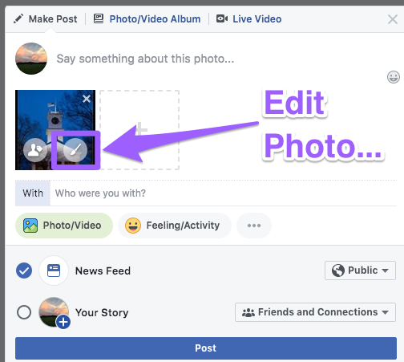

Then, in the left-hand pane, select Alt Text and click “Override generated text”. Enter your alt-text into the box and click save!

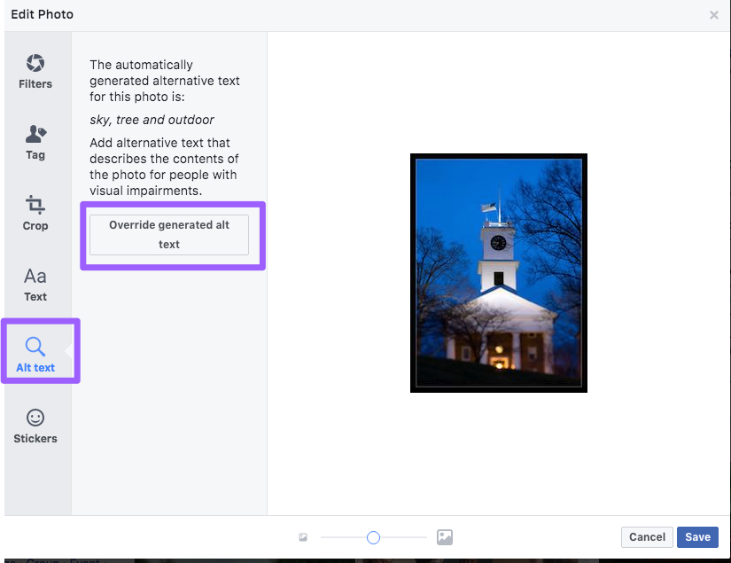
For platforms such as Instagram that don’t support alt text, image descriptions can be added within the text of the accompanying post.

If an image contains text (ie meme, flyer, etc) , type the text into your post as well.
Media posted or shared should have captions and/or text descriptions!

For more information and links to resources, please visit https://www.amherst.edu/go/ThinkAccessible

