Lab 11a for Math 17 – Beginning Regression – Part I

1. Class Brainstorm – What variables do you want to collect from the class for possible use in regression?

2. Finish working through examples from Friday (on handout from last week)

3. New Material – Chapter 9 and 10

Extrapolation:

Reminder about lurking variables and causation:

Multiple regression and variable transformations:

Example: Alligator Weight/Length
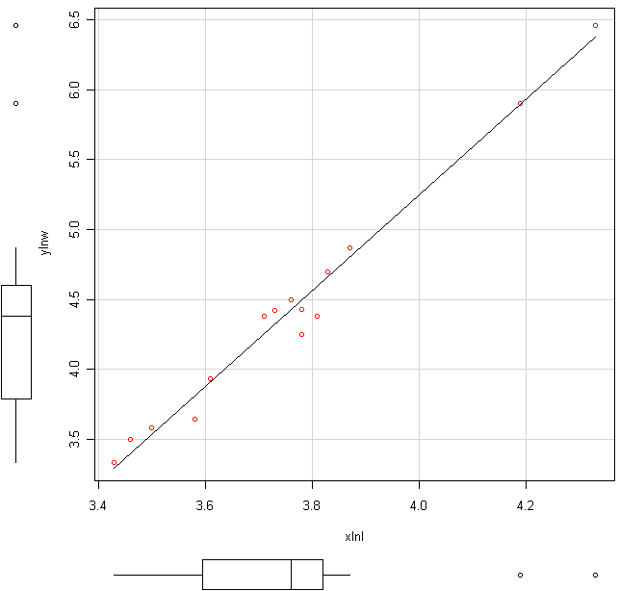
15 alligators had their weight (pounds) and length (inches) recorded. Both variables were natural log-transformed. Xlnl = ln(length), and ylnw = ln(weight).

mean sd 0% 25% 50% 75% 100% n
xlnl 3.758 0.2471032 3.43 3.595 3.76 3.82 4.33 15
ylnw 4.418 0.8560724 3.33 3.785 4.38 4.60 6.46 15

Residuals:
Min 1Q Median 3Q Max
-0.24348 -0.03186 0.03740 0.07727 0.12669

Coefficients:
Estimate Std. Error t value Pr(>|t|)
(Intercept) -8.4761 0.5007 -16.93 3.08e-10 ***
xlnl 3.4311 0.1330 25.80 1.49e-12 ***
---
Signif. codes: 0 '***' 0.001 '**' 0.01 '*' 0.05 '.' 0.1 ' ' 1

Residual standard error: 0.1229 on 13 degrees of freedom
Multiple R-squared: 0.9808, Adjusted R-squared: 0.9794
F-statistic: 665.8 on 1 and 13 DF, p-value: 1.495e-12
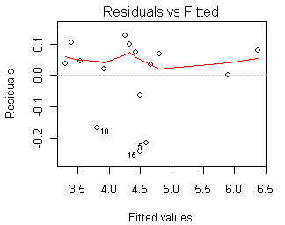

1. Report the estimated regression line.

2. Would it be reasonable to make a prediction for ln(weight) when x=ln(length)=5? Explain.

3. Are we able to say that changes in ln(length) cause changes in ln(weight)?

4. How well does the regression model fit? (Three things you can/should look at.)

Turn In Questions Name:

Circle your answer, either true or false, for each question.

1. Regression procedures are appropriate for studying a relationship between two categorical variables.
True False

2. Correlation/association implies causation. True False

3. Correlation coefficients (correlations) range from 0 to 1. True False

4. Simple linear regression was developed using a methodology called least squares. True False

5. A regression line allows you to make prediction for the explanatory variable based on the response variable. True False

6. The slope of a regression line tells you how much you expect the response variable to change on average for each one unit increase in the explanatory variable. (Change can be positive or negative). True False

7. R-squared measures how much of the variation in the predictor variable is explained by the linear relationship between the predictor and response. True False

8. Residuals are computed by taking the observed value of the response at a given predictor value and subtracting the predicted value of the response at the same predictor value. True False

9. A correlation value alone will indicate whether linear regression is appropriate. True False

10. A nonlinear relationship between X and Y will always result in a correlation of 0.
True False

