Data Set 1: Aphasia

Type Frequency Relative Frequency
Anomic 10
Broca 5
Conduction 7
Total 22

Appropriate Plot:

Data Set 2: Class Collected

Appropriate Plot:

Histogram Examples:

Example 1: Example 2:
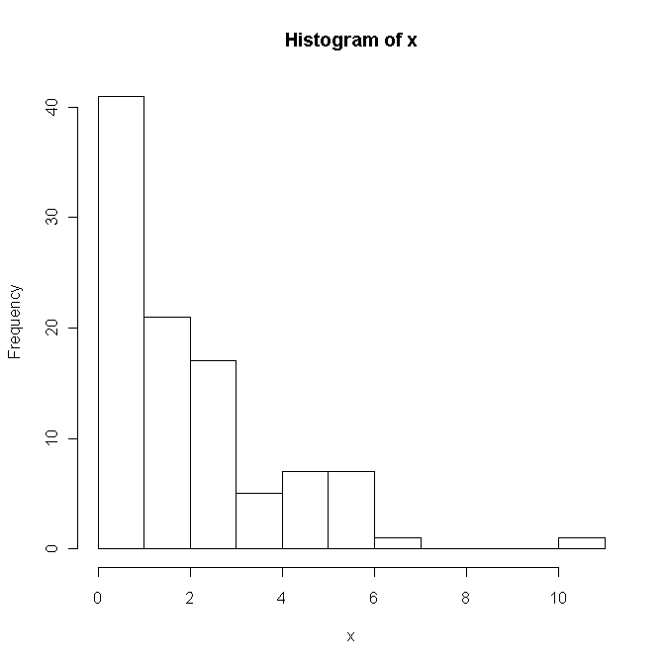
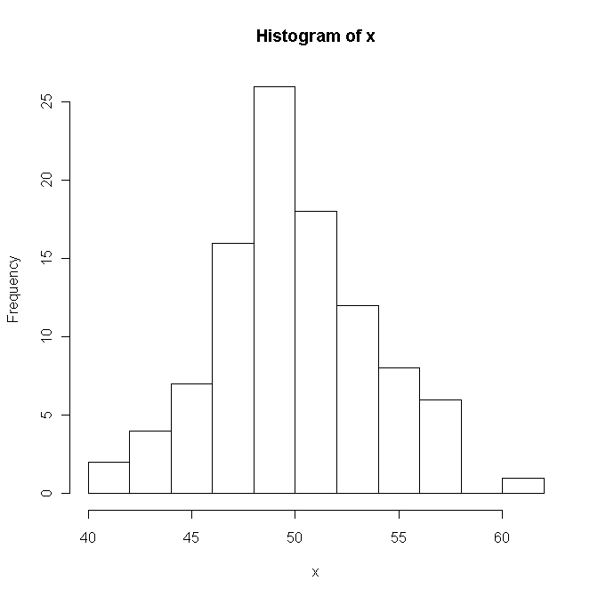

Example 3: Example 4:
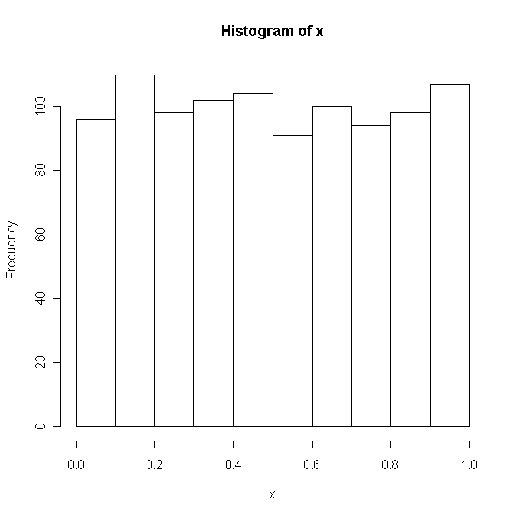
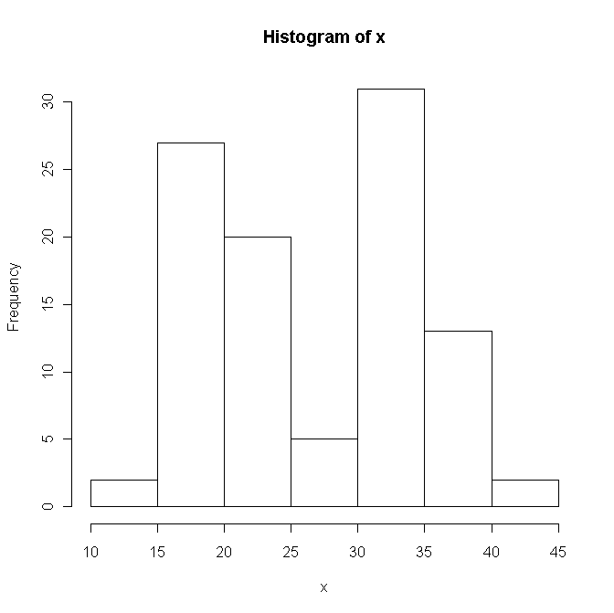

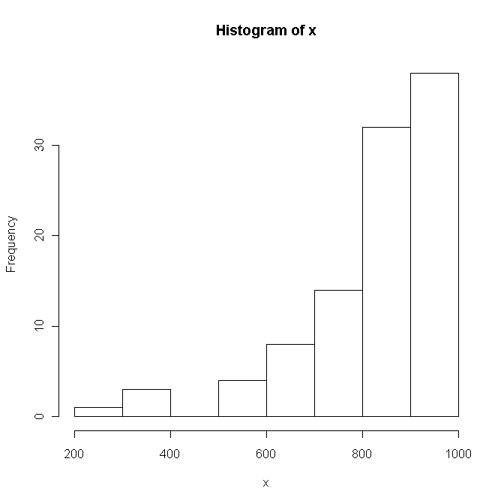
Example 5:
Data Set 3: Bicycle Accident Data

Age @ Death | Frequency | Relative Freq. | Class Width | Density
5-<10 | 4 | 4/50=.08
10-<15 | 4 | .08
15-<20 | 7 | 7/50=.14
20-<25 | 4 | .08
25-<45 | 19 | 19/50=.38
45-<65 | 9 | 9/50=.18
65-<90 | 3 | 3/50=.06
Total | 50 | 1.00 | NA | NA

Inappropriate Graph due to unequal class widths:

Appropriate Graph with density to make up for unequal class widths:

Data Set 4: Chemical amounts in drinking water

6 observations sampled during a particular month: 230, 180, 200, 270, 210, 170

Mean:

Median:

Range:
Q1:
Q3:

IQR:

Standard Deviation:

Obs (x) | $$x−\bar{x}$$ | $$(x−\bar{x})^{2}$$
170
180
200
210
230
270
Total

Example boxplot: Boxplot with outlier after changing 270:

Outlier computations:

