Note: This is not the same data set as the one for Spring 2011. Amy Wagaman
Math 17/ENST 24

Example Lab Work Solution

The Roosevelt National Forest in Colorado has been studied extensively. We are interested in comparing four wilderness areas (Rawah, Neota, Comanche Peak, Cache La Poudre) in terms of the frequency of a specified soil type from the Catamount family as well as in terms of hillshade index at noon. First, we note that the soil type variable is binary (only taking the values 0 and 1). It is an indicator variable because 1 indicates presence of the soil type while 0 indicates absence. We should treat this variable as a numerically coded categorical variable. Hence we will use a frequency table to display the distribution of this variable. Next, we consider the hillshade index at noon. A quick glance at the data set reveals this is a quantitative variable. Hence, we may use graphs such as boxplots and histograms, and descriptive statistics to describe its distribution and compare the areas. However, we will not know if we should focus on mean or median until looking at the graphs. We cannot use a bar chart or pie chart to display the hillshade index variable because it is quantitative, not categorical.

Sample Distribution of Soil Type

Looking at the soil type variable first, we see that not all wilderness areas appear to have this soil type (at least based on this sample). Rawah and Cache La Poudre had no instances of it in the random samples of size 500. We see that it is present in Neota and Comanche Peak, but more common in Comanche Peak. All in all comparing the areas in terms of this variable does not seem to be very interesting.
Area | Count (Presence) | Sample size | Frequency
Rawah | 0 | 500 | 0
Neota | 5 | 500 | .01
C. Peak | 29 | 500 | .058
Cache | 0 | 500 | 0
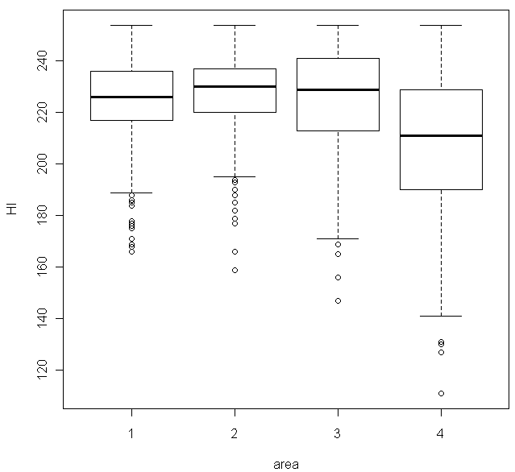
Swapping to looking at hillshade index at noon, we choose to display a side-by-side boxplot of the data after describing how a boxplot is made. Briefly, a boxplot is constructed using the five number summary of a variable (min, max, median, first quartile, third quartile), with special rules to deal with outliers (observations which are more than 1.5*IQR outside the middle 50% of the data (IQR=Q3-Q1)). In the case of this side-by-side boxplot, a boxplot is constructed for each area and then they are shown together on the same scale for easier comparison. This is a nice tool for comparing the areas. We note that the areas are labeled as follows: 1=Rawah, 2=Neota, 3=Comanche Peak, 4=Cache La Poudre in the boxplot (I chose not to relabel them when converting to a factor).

From the boxplot, we see that three of the areas have a similar median value for hillshade index, while Cache La Poudre has a lower median value. Cache La Poudre also appears to have the largest spread (based on both IQR and range). We note that there appears to be an upper bound on the hillshade index, as all areas share a maximum value of 254. All areas have some lower outliers, and we might suspect that these distributions are left-skewed due to the longer length of the lower whisker than upper whisker. This suspicion about shape will need to be confirmed by histograms.

Next, we examine descriptive statistics and shapes of the distributions via histograms (not shown) for hillshade index by region.

Area | Mean | SD | Median | IQR (Q3-Q1) | Shape
Rawah | 224.772 | 15.96 | 226 | 236-217=19 | Unimodal, left-skewed
Neota | 227.274 | 14.62 | 230 | 237-220=17 | Unimodal, left-skewed
C. Peak | 225.540 | 19.84 | 229 | 241-213=28 | Maybe bimodal, left-skewed
Cache | 207.624 | 27.60 | 211 | 229-190=39 | Unimodal, left-skewed

Looking at the reported shapes of the histograms, since we see skewness in all cases, we should focus on comparing medians and IQRs rather than means and standard deviations. This is because the mean and standard deviation (since it is based on the mean) are sensitive to skewness and especially outliers, while the median and IQR are robust to outliers. Comparing the medians and IQRs simply reinforces what we saw earlier in the boxplots. The first three regions have very similar medians. Cache La Poudre’s median is lower. In terms of spread (IQR), Rawah and Neota appear to have a similar small spread, Comanche Peak has a slightly larger spread, and Cache La Poudre has the largest spread. (We note that this same pattern is present in the means and standard deviations.)

In conclusion, we found that the soil type specified for this investigation was only present in two of the four wilderness areas, and found some similarities in center and spread for the hillshade index, with Cache La Poudre being the area that was very different in each measure.

