Standardization Practice + Normal Model (Devore and Peck)

The EPA tests for pollutants in motor vehicle emissions. An article from 1980 suggests that the emissions of nitrogen oxides may be modeled using a normal distribution. Assume the population mean is 1.6 and population standard deviation is .4 (units not provided).

Use appropriate notation to fill in the blanks. _____ = 1.6 and _____ = .4

An investigator completes a test on a car and observes an emission of 1.8. What is the z-score for the car? Do you need a normal model to compute a z-score?

Using the normal model, what is the probability a car has a higher z-score than the car with an emission of 1.8?

Using the normal model, in roughly what range of values would 95% of all car emissions fall if the mean and standard deviation provided are accurate?

Provide a value for a car emission that you think is extreme based on the N(1.6, .4) model. What z-score does that emission have?

The worst 10% of cars (highest emissions) have emissions higher than _________. (Reverse problem)

For Your Review:

Researchers conducting a survey received answers from 1-10 for each of 10 questions on the survey. Results from one question are displayed in the plots below. Use the plots to answer the questions.
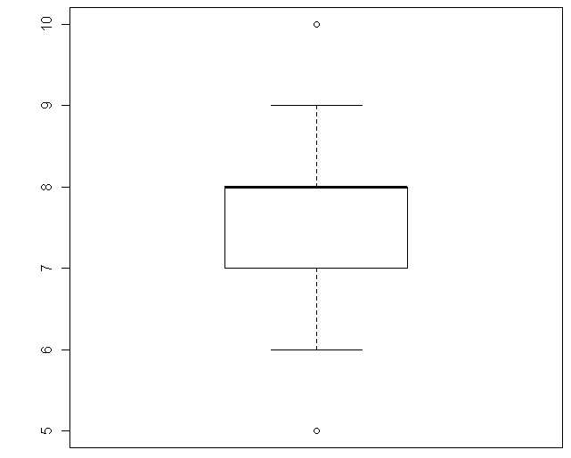
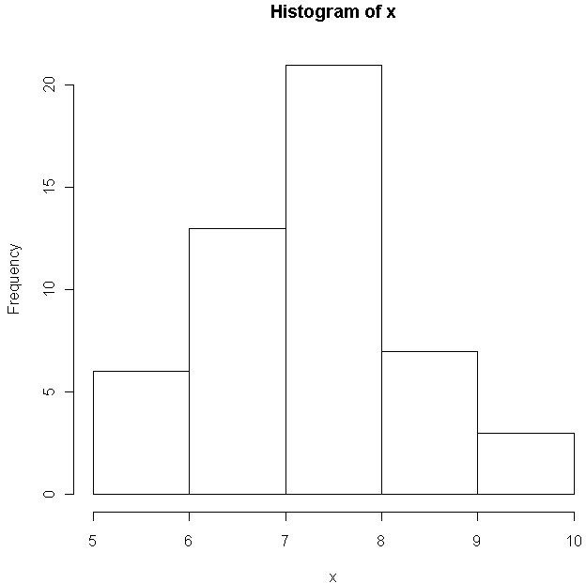

1. What was the most common value of a response to this survey question?
2. What is the most unusual feature of the distribution visible on the boxplot?
3. Verify the outlier calculations.

4. Describe the distribution of the responses to the survey question, addressing the shape, center, and spread of the distribution.

General Questions.
5. True or False. When computing the range for a quantitative variable, you ignore outliers.
6. True or False. Outliers must always be the maximum or minimum values of a quantitative variable.
7. True or False. If a distribution is bimodal, it cannot be symmetric.

8. Violations of the Area Principle may occur when looking at either ____ graphs or ____ charts for categorical variables.
9. The table that is used to show the frequency of observations in categories for 2 or more categorical variables at the same time is called ______________________________.

10. When looking at aggregate percentages based on categorical variables, you should be careful of _______________ Paradox.

