ART LESSON PLANS
- Illustrated Words
Source: http://www.princetonol.com/groups/iad/lessons/high/wendy-drawing.htm

Objectives

- Use images and lettering style to communicate the meaning of a specific word chosen for the composition.
- Consider elements and principles in design.
- Acquire colored pencil technique

Procedure

- Brainstorm ideas for subject – words that are personally meaningful and interesting.
- Make a list of images that can be associated with the chosen word.
- Sketch rough draft in pencil. Design "font" to communicate aspect of word, too. Refine and enlarge for final composition.
- Practice a tonal scale from light to dark with choice of colored pencil – main color first, then mix with light analogous, dark analogous, and complement. Practice colored pencil techniques for layering, blending, and creating value.
- Finish final composition by adding color according to the assigned/selected scheme.
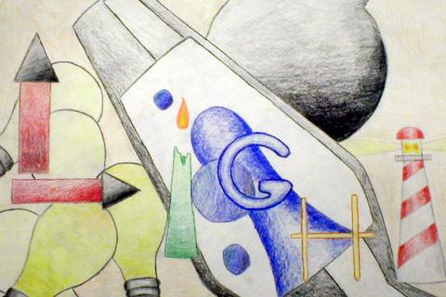

- Abstract Expressionism Collage
Source: http://www.princetonol.com/groups/iad/lessons/high/kenabstract.htm

Objectives
- Gain an understanding and appreciation of abstract expressionism -
Learn how an artist works/gets ideas.
- Combine collage with painting techniques to create a composition
around a selected theme.
- Integrate technology - use Internet to locate images.
- Employ elements and principles of design in creation of abstract
composition.
Procedure
  - Look at the work of Robert Rauschenberg. Study the use of large painted areas with collages of pictures and found items on them. Study the use of vertical horizontal movement and the quick loose brush strokes.
  - Find a theme or concept to paint. Collect pictures (real photographs, internet images, images from magazines or old books) and/or real items to use in the collage.
  - Plan out the placement of the pictures to have an area of emphasis and to create directional movement and rhythm. Remove these and start with some quick brush strokes to set the painting’s movement and direction. Follow this with the lamination of the photos and printouts, using white glue and a big brush. Layer the glue and water over and under the photos quickly so as not to blur them.
  - After these dry begin to paint into the pictures and outside of them to tie these together. Balancing of values, colors and shapes will help pull it all together.
  - Adding of real objects and things can be done with a hot glue gun. Remember to have fun and think of compositional rules. Take a look at Rauschenberg examples often to point out good design and composition as well as his technique.
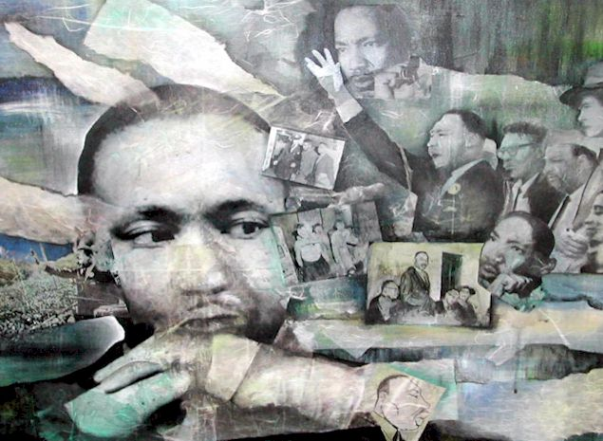
- Photocubism Photo Collage (Inspiration: artist David Hockney)
Source: http://www.princetonol.com/groups/iad/lessons/high/mike-hockney.htm
Procedure
- Compose a photo with a strong center of interest. Since you will be taking pictures of a very wide area, you should keep your center of interest very close.
- Remember, never to move from your spot until you’re done. You may tilt the camera up and down during the shoot, but never change your shooting position.
- Practice shooting first. The idea behind Hockney’s approach is to photograph a large scene by breaking it up into many smaller ones. You must think of your scene as having an invisible grid with overlapping squares placed upon it. Begin shooting with only your waist turned three-quarters to the left. Continue to shoot your first horizontal row of photos, remembering to always overlap the photo you just took, until you reach a position where your waist is turned three-quarters to the right.
- Begin to shoot the second row of horizontal photos as you did previously, but you must also overlap the top of this row with the bottom of the last row.
- Continue to shoot the entire scene always overlapping both vertically and horizontally until you complete the scene.
- Shoot the real thing when you feel comfortable.
- Once you have printed your photos, reconstruct the scene you photographed in a photo collage
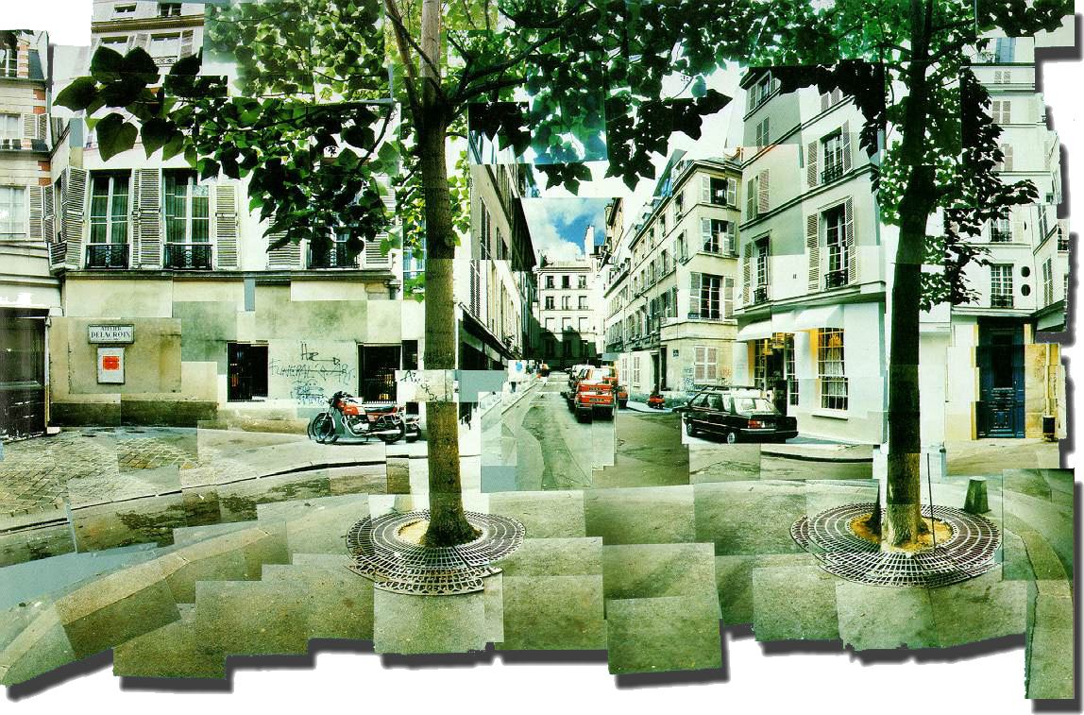

- Cultural Portraits
Source: http://www.princetonol.com/groups/iad/lessons/high/Kim-Portrait.htm
Project description
In this portrait project, you will depict yourself as a member of a tribe or culture of which you are not actually a member. You will work from a digital photograph of yourself as well as images that are taken from an actual tribe/culture, such as the Maasai, the Zulus, etc. Research the tribe/culture you wish to identify with. By adding features such as piercings, tattoos, body adornments, hairstyles, etc. that are indicative of that tribe/culture, you will become a “member” in your drawing. Why do you identify with that particular cultural group? What do you admire about these people? ***Variation*** Research their own ancestry and do a self portrait reflecting their own cultural heritage. Students could even invent their own "tribal look" based on research.
Procedure
  - Select images from the Internet that you want to use as reference materials for the additions you are going to make to your self-portrait. Print the images that you want to use.
  - Get your photo taken. But first, decide what type of expression you want to have on your face. You might get an idea by looking again at the images you found either on the net or in a book from the library. It is helpful to look at the expression right before you are photographed so you can envision it on your face. You also need to decide how your face/head need to be positioned before you are photographed.
  - Using your photograph, do some small, quick, non-detailed thumbnail sketches of your composite face. This helps you plan it out ahead of time so you will create the best composition. Remember this is a portrait. This means head, neck and some shoulder showing.
  - Once you have completed the previous steps and are ready to start on your final, lightly sketch the entire composition onto your final paper. Make sure that you have the correct proportions. This is a realistic portrait. You may want to grid part of your face to get it just right. Add all the tribal/cultural adornments and additions by looking at the image you printed in step one.
  - Lay in all the correct values. There should be complete whites, complete blacks and all the values in between. It should look as close to a photograph when you are done as possible.
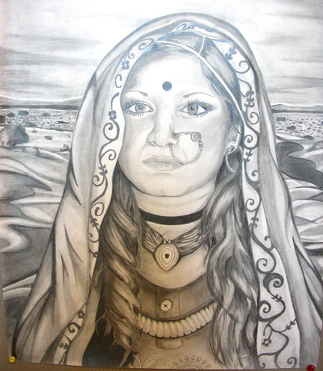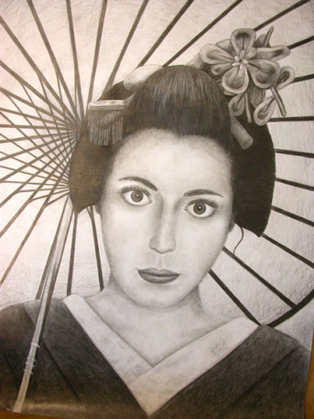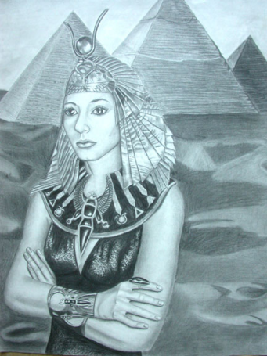
- Sidewalk Chalk Festival
Source: http://www.ehow.com/how_1335_street-painting.html

Procedure
- Select an image that you can re-create with chalk. Traditional street painters select works from the masters (Raphael or Michelangelo, for example), though you may want to re-create a modern piece or your own original artwork. Selecting a photograph is also popular.
- Make color photocopies of the painting you'll be re-creating. Several copies will be needed, especially if more than one artist will be working on the piece.
- Draw a grid over the photocopies using a ruler and thin marker. Half-inch squares are ideal. Measure carefully so that all photocopies are gridded identically. Label the graphed columns on your photocopies horizontally with alphabetical letters and vertically with numbers. Mount photocopies on cardboard to make them easier to work with.
- Measure out an area for your street painting, usually a square or rectangular shape. Measure out the four corners and then use a carpenter's chalk line to mark straight lines on the pavement. Affix masking tape to the pavement along the chalk lines to create sharp borders.
- Using a tape measure and marker, measure out points on the masking tape that will be used to create a grid on the pavement. The graph will need to correspond to the grid on your photocopied picture. Measurements will differ, but a good ratio of pavement-square size to photocopy would be one 6-inch square on the pavement per half-inch square on the photocopy
- Line up the chalk line first to the horizontal and then to the vertical points marked on the masking tape. Snap the chalk line to mark out the grid on the pavement. Label the masking tape border with the letters and numbers that correspond to those noted on the photocopy of the image. These will serve as location guides.
- Use your photocopy and grids to guide you as you chalk out a rough outline of the complete image you are painting on the pavement - just enough to map out the image and get the proportions correct.
- Start from the top of the painting area and begin painting the image with the colored chalk. Lay a foundation of color using your fingers in small areas and a chalkboard eraser for larger areas. Fill in the details of the image using various shades of colored chalk. Continue to blend colors to gain the right effect. Leave some chalk color unblended on the surface of the pavement to bring out colors, highlights and details. Work your way down the area of your painting.
- Remove the masking tape to reveal clean, crisp outlines. Sign your work. If you've reproduced an image originally created by another artist (living or deceased), give the artist credit by noting his or her name and the title of the piece at the bottom of the street painting.

***Inspiration***
A sidewalk chalk artist at work:
http://www.youtube.com/watch?v=6r2joM0dntQ&feature=player_embedded#!
6. “Too Loose” Posters
Source: http://www.princetonol.com/groups/iad/lessons/high/high3.html

Procedure
- Students will review the works of Henri Toulouse-Lautrec, focusing primarily on the works of his advertising posters.
- Students will view current full page ads and posters and compare those with Toulouse-Lautrec.
- Students will design and sketch out a poster that will advertise something from the present: a local/global event or a social justice issue.
- Students will then paint (or print) the poster in the style of Toulouse-Lautrec. Various other media may be used for the poster, such as silk screening.
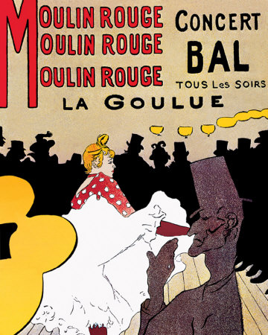
An advertising poster by Toulouse-Lautrec

7. Product Design
Source: http://www.princetonol.com/groups/iad/lessons/high/Cindi-dream.htm

Procedure
“I directed my students to observe all packaged products. I had several on display in the classroom. We had discussions about line, color, subject, and how each element could be displayed on a container to catch the consumer’s eye. Students were told to focus on what their idea of the American Dream was. Concepts discussed were money, love, happiness, employment, and environment. Once the students decided on their American Dream they were instructed to give it a title make it a product. When the students had gotten that far they were told to design a container and a flier to sell their product, as if it were in a super market and advertised in the newspaper. Students had to include an image of themselves, ingredients which depicted themselves, and a logo on both the container and the flier. The students were to use colored pencil, however any medium provided it was effective was allowed. Craftsmanship was mandatory. Graphic design students photographed the images, animated the images, and saved everything to disc. Critiques followed when all students were finished.”
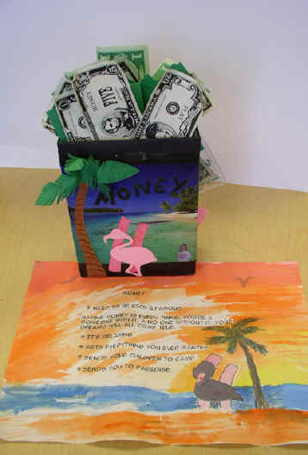

8. A New Community
(Inspiration: artist/architect Friedrich Hundertwasser) http://www.hundertwasser.at/index_en.php
Procedure
- Observe and discuss the art of Friedrich Hundertwasser, an Austrian painter, architect and ecologist.
- Integrate Hundertwasser’s ideas and techniques to create a two-dimensional image or three-dimensional model depicting a new, ideal community (using various media).
Resources
For a complete, student-friendly explanation of Hundertwasser’s ideas and techniques, consult this lesson plan: http://www.projectarticulate.org/lessons/hundertwasserArchitect.pdf

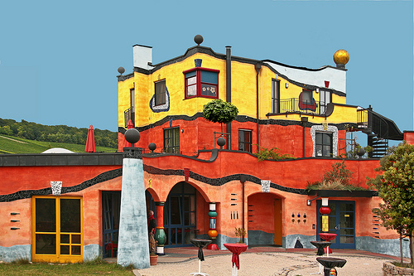
An example of how Hundertwasser envisioned a community.

9. Paper Plate Collage: What is beauty?
Source: Girlz II Women Program curriculum (from Amherst College Center for Community Engagement)

Objectives
- Students will explore and accept who they are as individuals in terms of appearance, racial/ethnic background, abilities/disabilities, personality, etc.
Procedure
- Students will look through magazines in search of pictures of beautiful people. They will cut out these pictures and arrange them in a collage on one side of a paper plate.
- On the other side of the paper plate, students will write what qualities they believe define beauty on the inside.
- The teacher will engage students in a discussion considering the following questions:
- What is considered beautiful in magazines? In the media? In mainstream society? What is missing in this conception of beauty?
- What are the differences between the words and the images on the two sides of the plate?
- What is the difference between physical beauty and other kinds of beauty? Which kind of beauty is most important?
- How can we challenge the media and mainstream society to alter their conceptions of what is beauty?

10. “Me in the present, me in the future”
Source: Girlz II Women Program curriculum (from Amherst College Center for Community Engagement)

(This activity relies on video technology)
Procedure
- Students are given the opportunity to interview each other with a video camera. Two chairs are set up in front of the room. In the first chair, the students are asked to answer questions about their lives today. When they sit in the second chair they are instructed to talk about their lives 10 years from now (in the first person).
- The group will ask questions such as: Where do you work? Are you in college? Where do you live? What car do you drive? Do you have children? How did you become a success? What challenges have you overcome?
- The group will then discuss the difference between their present and future selves. They will discuss what their goals are and what they can do to achieve those goals.

