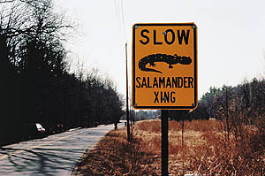
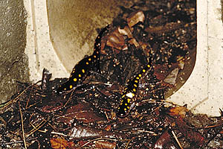
Salamander Crossings! (Independent Samples t-test)

Suppose you wanted to take advantage of the salamander crossings in Amherst to study differences between sexually mature males and females – age differences, size differences, etc.

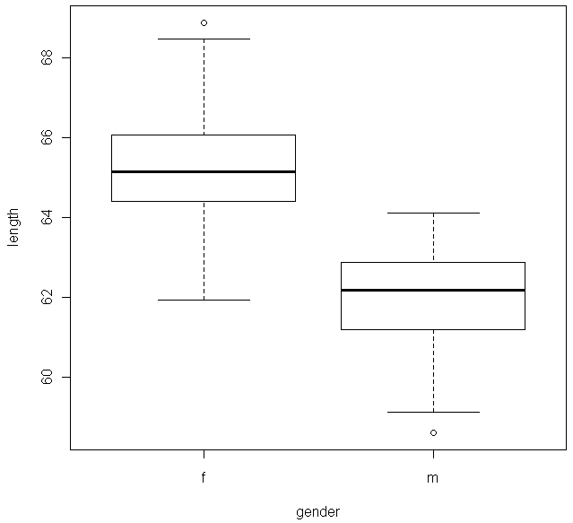
You obtain a sample of (spotted) salamanders heading through the tunnels, and record their gender and length in mm.

What hypotheses are you able to test with this data set? (You may pick the alternative). Set up hypotheses and choose significance level.

Your sample of 35 males and 42 females results in the following descriptive statistics and graphs. Does it appear to be appropriate to use a two independent samples t-test? (More graphs on next page).
mean sd 0% 25% 50% 75% 100% n
f 65.27357 1.602814 61.92 64.4425 65.145 66.035 68.90 42
m 62.00857 1.300487 58.59 61.1800 62.180 62.880 64.11 35

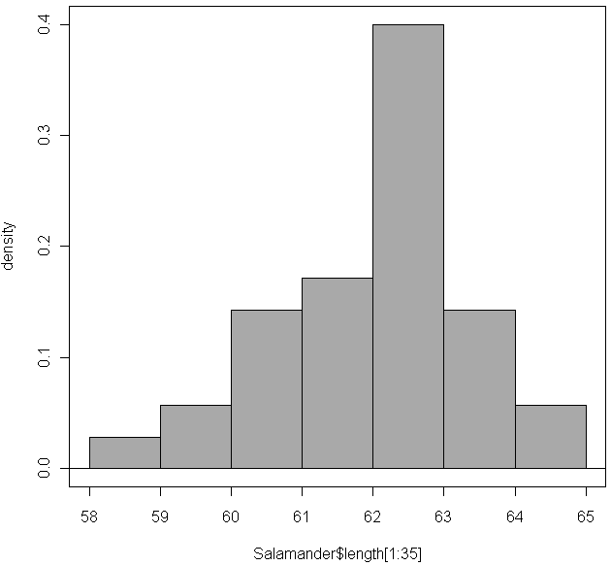
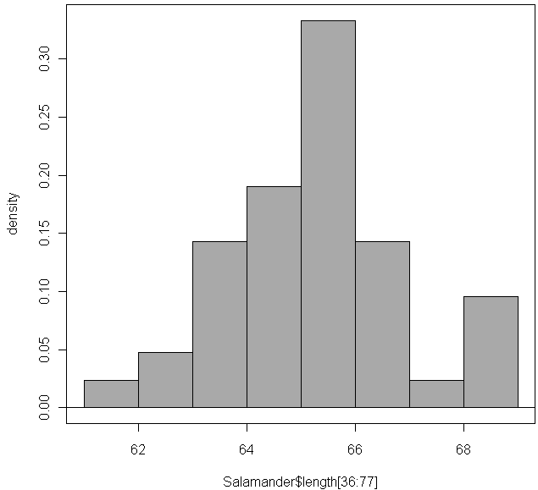
Complete the test by giving your test statistic, p-value and a conclusion based on the R output below but consistent with your hypotheses (Remember you can find a p-value for any test based on the two-sided p-value).

Welch Two Sample t-test

data: length by gender
t = 9.8673, df = 74.956, p-value = 3.415e-15
alternative hypothesis: true difference in means is not equal to 0
95 percent confidence interval:
2.605825 3.924175
sample estimates:
mean in group f mean in group m
65.27357 62.00857

Test statistic:
p-value:
Conclusion:

Interpret your test statistic:

