Lead/Copper Data Analysis (using R, which is free software if you want to download it)
lead=c(1.32,0,13.1,.919,.657,3.0,1.32,4.09,4.45,0); hist(lead)
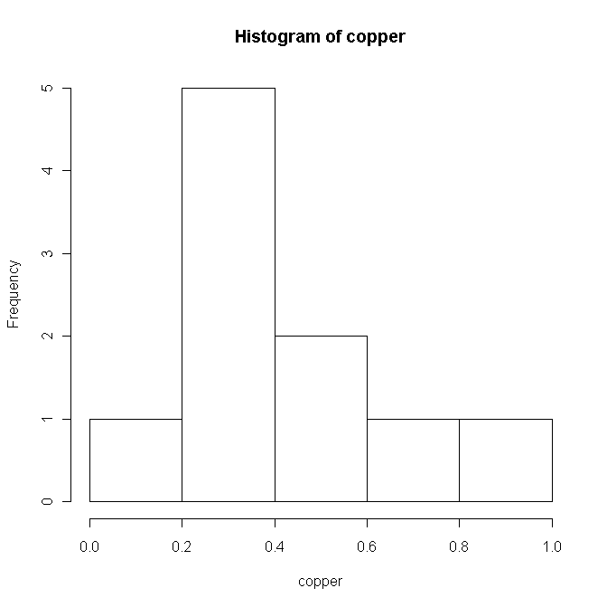
copper=c(.508,.279,.320,.904,.221,.283,.475,.130,.220,.743); hist(copper)
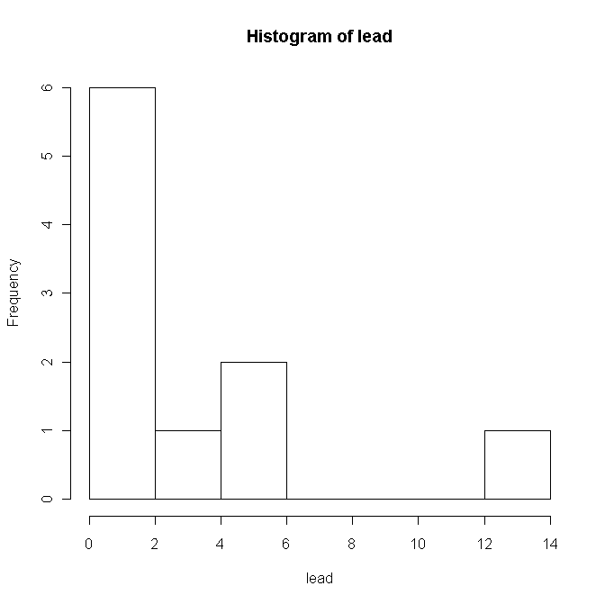
QQ plots (qqnorm(lead);qqline(lead) and similar command for copper) show that lead doesn’t appear to follow a normal distribution. Copper appears okay though, so we focus on that metal.

summary(copper) <- general summary command
Min. 1st Qu. Median Mean 3rd Qu. Max.
0.1300 0.2355 0.3015 0.4083 0.4998 0.9040

sd(copper) <- sample standard deviation command
0.2495187

length(copper) <- to get sample size, n
10

Finding t quantiles for cutoffs:
qt(.975,12) would give you the 97.5% percentile for a t with 12 df (i.e. for 95% CI)
qt(.995,20) would give you the 99.5% percentile for a t with 20 df (i.e. for 99% CI)

Values you might need:
qt(.995,9) =3.249836
qt(.995,24)=2.796940
qt(.995,34)=2.728394
qt(.995,96)=2.628016
qt(.955,106)=2.623008

