Biting Fly Analysis for Homework 8

Note: Not all output is relevant. You have to choose which pieces to use and which to ignore.

diff=lseg12-lseg13
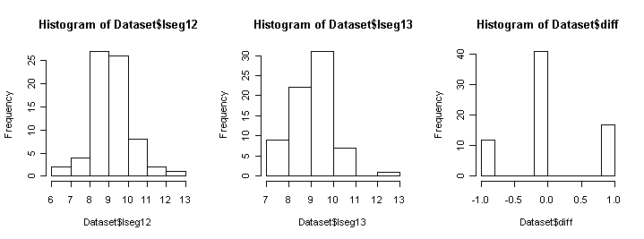

mean sd 0% 25% 50% 75% 100% n
diff 0.07142857 0.6442933 -1 0 0 0 1 70
lseg12 9.61428571 1.0940267 6 9 10 10 13 70
lseg13 9.54285714 1.0026879 7 9 10 10 13 70

Paired t-test
data: Dataset$lseg12 and Dataset$lseg13
t = 0.9276, df = 69, p-value = 0.3569
alternative hypothesis: true difference in means is not equal to 0
95 percent confidence interval:
-0.08219775 0.22505489

Welch Two Sample t-test
data: variable by factor
t = 0.4027, df = 136.964, p-value = 0.6878
alternative hypothesis: true difference in means is not equal to 0
95 percent confidence interval:
-0.2793147 0.4221719
sample estimates:
mean in group lseg12 mean in group lseg13
9.614286 9.542857

