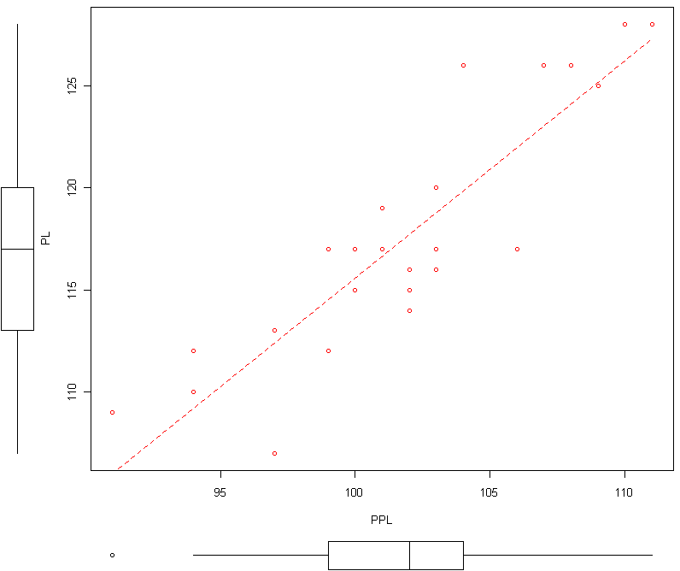
Wolfskulls Analysis for Homework 9

Note: Not all portions of output are relevant analysis. You must decide which pieces to use.

Call:
lm(formula = PL ~ PPL, data = Dataset)
Coefficients:
Estimate Std. Error t value Pr(>|t|)
(Intercept) 9.1213 11.7983 0.773 0.447
PPL 1.0645 0.1159 9.185 3.71e-09 ***
---
Signif. codes: 0 '***' 0.001 '**' 0.01 '*' 0.05 '.' 0.1 ' ' 1

Residual standard error: 2.866 on 23 degrees of freedom
Multiple R-squared: 0.7858, Adjusted R-squared: 0.7765
F-statistic: 84.36 on 1 and 23 DF, p-value: 3.708e-09

Call:
lm(formula = PPL ~ PL, data = Dataset)
Coefficients:
Estimate Std. Error t value Pr(>|t|)
(Intercept) 15.04954 9.44386 1.594 0.125
PL 0.73816 0.08037 9.185 3.71e-09 ***
---
Signif. codes: 0 '***' 0.001 '**' 0.01 '*' 0.05 '.' 0.1 ' ' 1

Residual standard error: 2.386 on 23 degrees of freedom
Multiple R-squared: 0.7858, Adjusted R-squared: 0.7765
F-statistic: 84.36 on 1 and 23 DF, p-value: 3.708e-09
Additional Output:
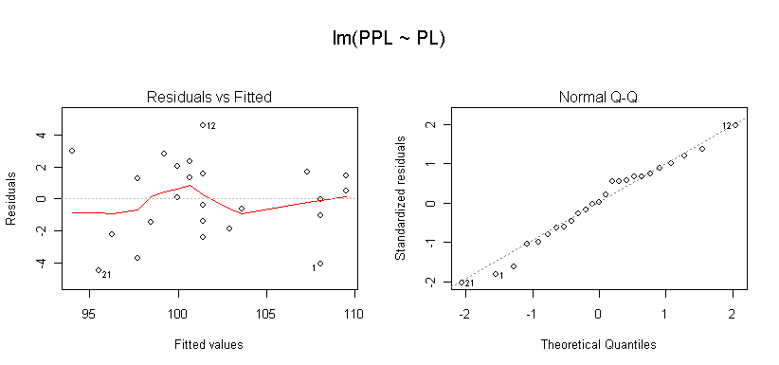

Residuals:
Min 1Q Median 3Q Max
-4.50898 -1.46162 0.06206 1.58574 4.58574

