Lab 10 for Math 17 – ANOVA

Ocean Water Temperatures

NOAA (National Oceanic and Atmospheric Administration) records water temperatures at selected sites around the United States throughout the year (among other characteristics). The sites are divided among many regions and sub-regions. For example, the Atlantic coast region is divided into North, Central, and Southern sub-regions. The average water temperature at each site for a period of 2 weeks is recorded and displayed on the NOAA website. The water temperatures we are investigating in this exercise are the average temperatures from July 1-15 of 2009 (source: NOAA).

Consider first the Atlantic coast region with its three sub-regions. The data is contained in AtlanticJulyTemp.txt. Assume the temperatures selected from each sub-region are a random sample of the average temperatures from the region.

What temperature differences do you expect to see between ACNorth (Atlantic Coast North), ACSouth, and ACCentral?

Perform a preliminary analysis of the data. You can make histograms and QQ-plots before stacking the data, but will then need to stack the 3 sub-regions to make a comparative boxplot and continue with the ANOVA. Does the preliminary analysis support your expectations in temperature differences?

Perform an ANOVA to determine if any temperature differences are actually significant and use multiple comparisons to identify any significant differences. After stacking the data, simply select One-Way ANOVA from the Means menu under Statistics. You should check the box for pairwise comparisons if you want the multiple comparisons output (you can always just run it again and check it later if needed).

Null: Alternative:

Parameter definition:

Assumptions/Checks:

Test statistic: Dist. of Test Stat.:

p-value:

Conclusion:

Multiple comparisons summary (if appropriate):

What would you give as the estimate of the common population variance for the temperatures in the Atlantic coast sub-regions?

Temperatures East to West

Finally, we will investigate possible differences in average water temperatures moving East to West across the southern United States. The data set SWaterJulyTemp.txt contains average water temperatures for sites in the southern Atlantic, east and west Gulf Coast, and southern Pacific.

What differences do you expect to see between these four regions? Sketch what you think a multiple comparisons output would reveal (i.e. make a prediction).

Open the data set, stack the variables, and make a comparative boxplot. What do you see from the boxplot?

Conduct the appropriate test to determine if there are differences in average water temperatures between these four regions and where those differences are if present.

Null: Alternative:

You may assume the assumptions hold.

Test Stat: p-value:
Interpret your p-value.

Conclusion:

Multiple Comparisons summary (if appropriate):

How accurate was your prediction?

Are Weights of Poplar Trees Affected by Different Treatments on Average?
(Data from Triola)

Random samples of poplar trees were subjected to 4 different treatments: no treatment, irrigation, fertilizer, and both irrigation and fertilizer. Each random sample consisted of 5 trees. The following partial ANOVA table was constructed. Assuming the assumptions for ANOVA are met, complete the table, perform the ANOVA and provide a conclusion to the question asked above.

 | DF | SS | MS | F | p-value
Treatment |  |  |  | 5.73 | .007
Residuals |  | 4.357 |  | - | -
Total |  |  | - | - | -

Hypotheses: Significance level:

Assumptions: (Assume they hold, but list here in context.)

Test statistic:

p-value:

Sketch and label the distribution used to compute the p-value.

Conclusion:

Does the ANOVA output allow you to conclude that irrigation and fertilizer combined perform better than the other three methods? Sketch an example multiple comparison summary that would allow you to make this conclusion.

To Turn In:
Archaeologists measure certain features of skeletons to shed light on changes over time for civilizations of interest. Three different Egyptian epochs were selected and a sample of 9 skulls from each epoch had their head breadth measured. Changes in time in head shape suggest interbreeding with immigrant populations. The three epochs were 4000 BC, 1850 BC, and 150 AD. (Data from Triola). Some descriptive statistics and a side-by-side boxplot are shown.
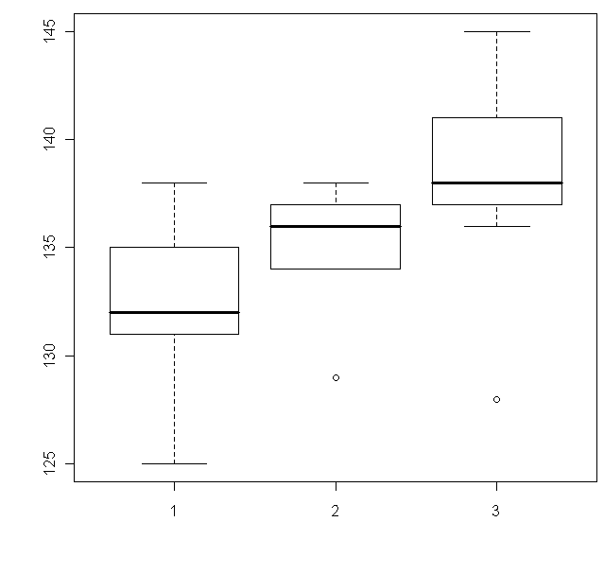
Epoch | 4000 BC | 1850 BC | 150 AD
Mean | 132.67 | 134.44 | 138.11
SD | 4.18 | 3.36 | 4.76

Here is partial Rcmdr output from the ANOVA:

AnovaModel.1 <- aov(breadth ~epoch)
summary(AnovaModel.1)

Df Sum Sq Mean Sq F value Pr(>F)
epoch 2 138.74 69.37 ?? 0.03052
Resid 24 411.11 17.13

You have decided to run an ANOVA to test for equality of the population mean head breadths for the three epochs. You may assume that the conditions for inference are satisfied. Use the output to answer the following questions:

1. Estimate the common population variance.

2. Compute the numerical value of the test statistic.

3. What is the distribution of the test statistic assuming the null hypothesis is true?

4. What is the p-value for the test?

5. What conclusion do you make? Do you need to generate multiple comparisons output?

Nonparametric Methods

The z-tests, t-tests, and F-test (ANOVA) that we have studied so far are parametric tests. In the end, the statistical theory driving each of the techniques comes down to normal distributions (via sampling distributions) but these are also related to distributional assumptions (such as nearly normal population(s) or at least 10 successes/10 failures in your sample). Nonparametric tests do not require that samples come from populations with normal distributions or any other specific distribution. Hence they are sometimes called distribution-free tests. They may have other more easily satisfied assumptions - such as requiring that the population distribution is symmetric. In general, when the parametric assumptions are satisfied, it is better to use parametric test procedures. However, nonparametric test procedures are a valuable tool to use when those assumptions are not satisfied, and most have pretty high efficiency relative to the corresponding parametric test when the parametric assumptions are satisfied. This means you usually don't lose much testing power if you swap to the nonparametric test even when not necessary. The exception is the sign test. The following table shows the parametric and corresponding nonparametric tests we have covered so far.

Parametric Test | Nonparametric Test
One sample z-test | Exact Binomial
One sample t-test (or paired t-test) | Sign test or Wilcoxon Signed Ranks test
Two independent samples t-test | Wilcoxon Rank-Sum test
ANOVA (F-test) | Kruskal-Wallis

If you are doing an analysis and your distributional assumptions are not met, you may want to try the nonparametric versions. This is another reason to consult with a statistician, as there are variants on these methods. Many of these methods end up working with ranks rather than the original data, which results in some interesting mathematics.

If you find that your distributional assumptions are not met for your projects and you want me to show you how to run these tests, just let me know. All of these are easily implemented in Rcmdr, but you might need some help reading the output.

Summary
- The techniques we have covered in class so far are parametric techniques.
- There are alternatives called nonparametric techniques.
- The difference is that nonparametric techniques do not make assumptions like having a nearly normal population, but (for example) might require an assumption of a nearly symmetric population.
- Better to use parametric tests if the parametric assumptions are satisfied.
- Consult with a statistician if your assumptions aren’t met and you want to see if another test can be used!

