Hypothesis Test/CI Example for a Population Mean

DDT concentrations in blood of 20 randomly selected people were collected (Devore/Peck) and are listed: 24,26,30,35,35,38,39,40,40,41,42,42,52,56,58,61,75,79,88,92.

Check all conditions and provide a 90% confidence interval for the concentration of DDT in the blood. Interpret the standard error, confidence interval and confidence level in the context of the problem. (The original population is not well described by the problem). Note the R output provided contains a 95% interval, but not a 90% interval.

Conditions and Interval Calculations:

Interpretations:

Standard Error:

Confidence Interval:

Confidence Level:

mean sd 0% 25% 50% 75% 100% n
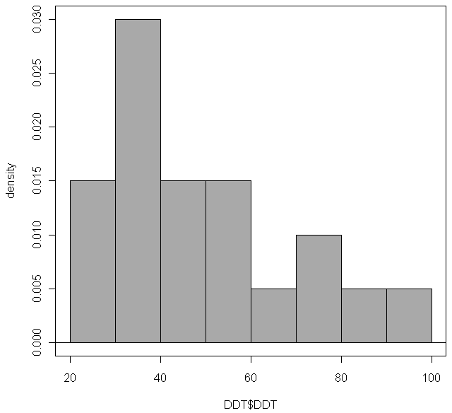
49.65 20.09523 24 37.25 41.5 58.75 92 20
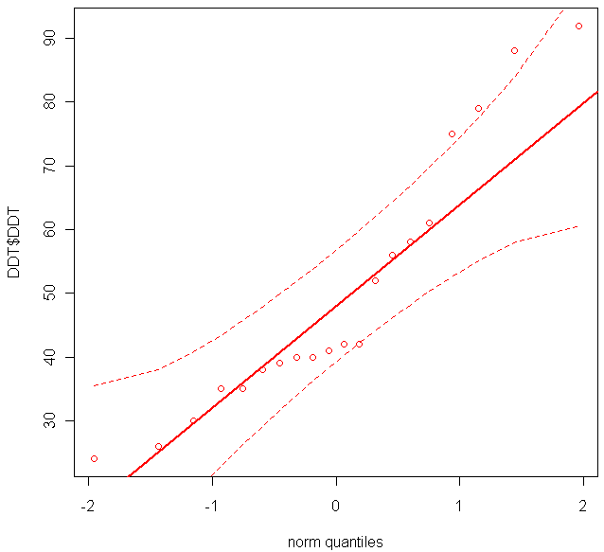
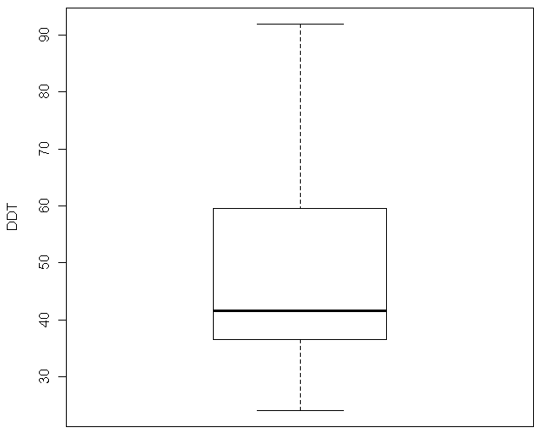
t.test(DDT$DDT, alternative='two.sided', mu=0.0, conf.level=.95)

One Sample t-test

data: DDT$DDT
t = 11.0495, df = 19, p-value = 1.030e-09
alternative hypothesis: true mean is not equal to 0
95 percent confidence interval:
40.24514 59.05486
sample estimates:
mean of x
49.65

