QQ Plots for some real data:
Airquality (which you had already taken a look at with other graphs):
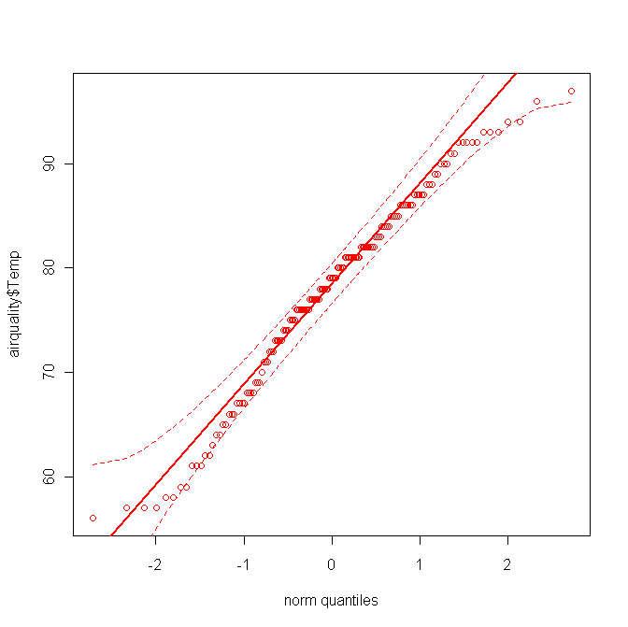
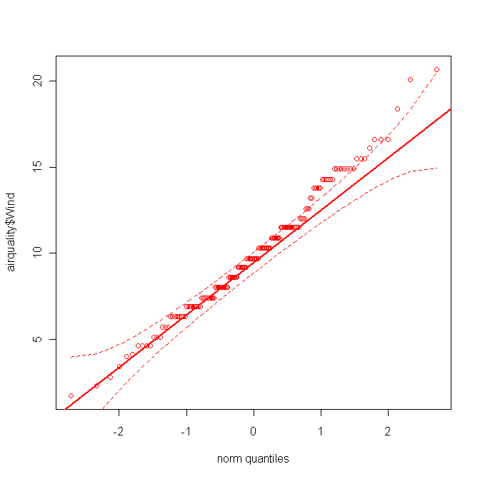
Temp Wind

Old Faithful Eruption/Waiting Times (note this is a heavily rounded version of this data):
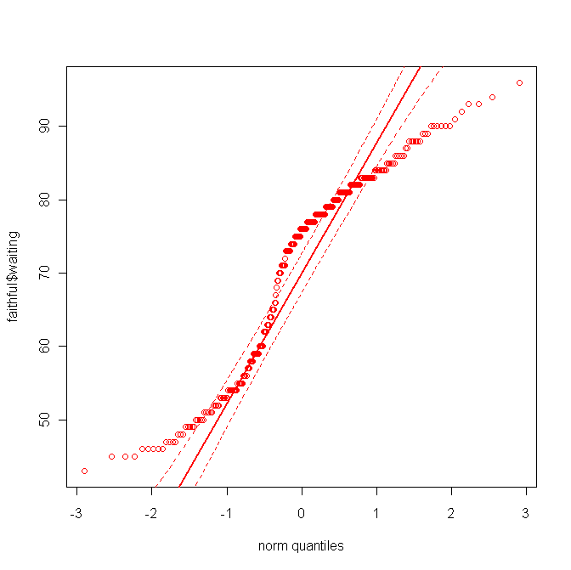
Eruption Time Waiting Time
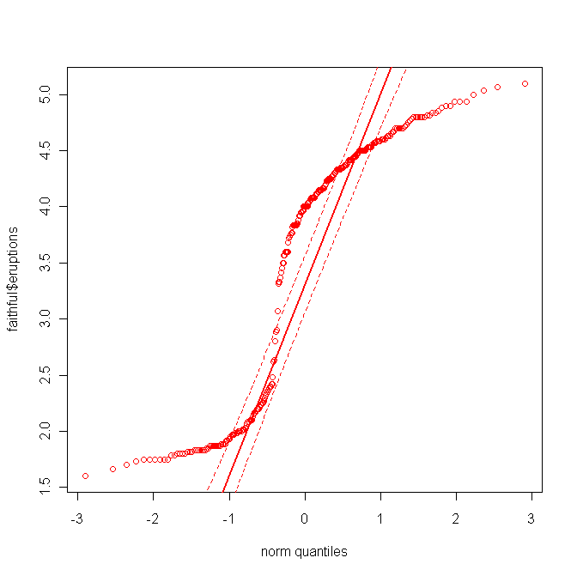

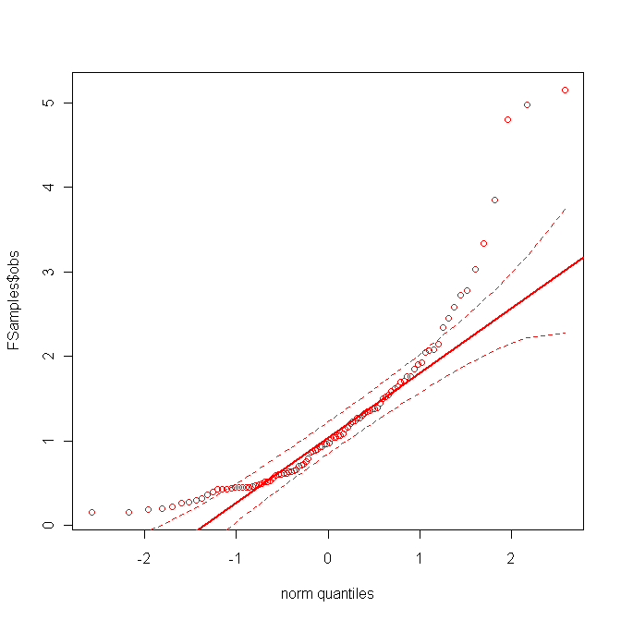
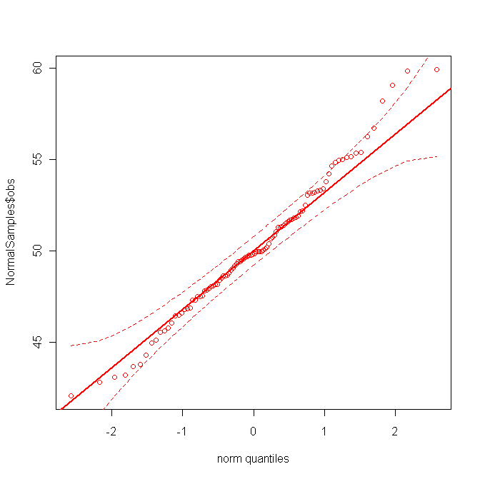
From an F Distribution From a Normal Distribution

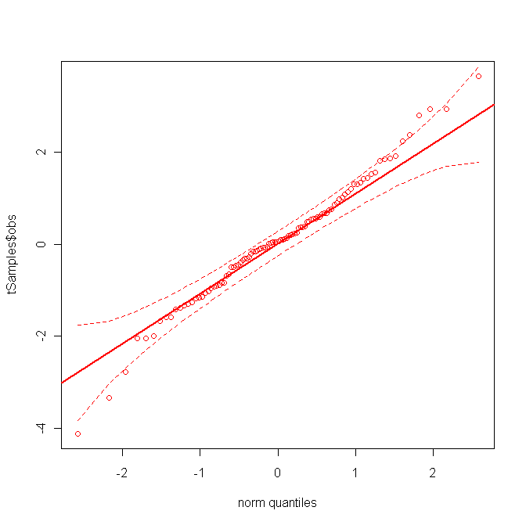
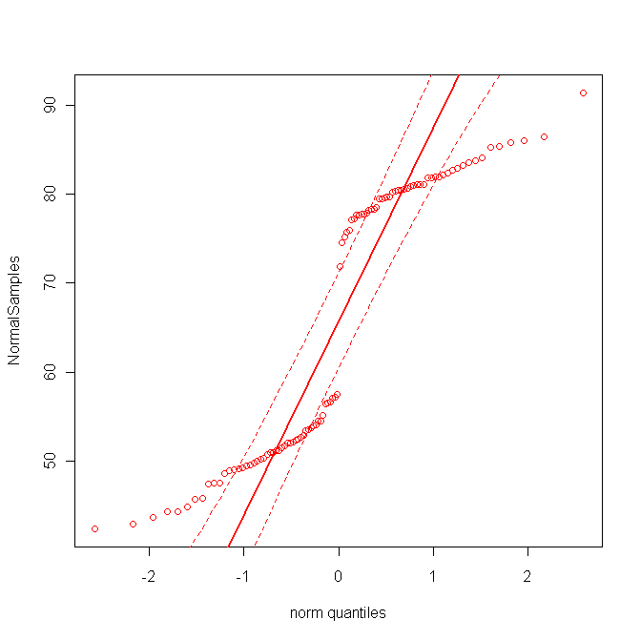
From a t Distribution From a Mixture of normals (i.e. 2 groups)

