Air Quality Example for Hypothesis Testing (Data from Bluman, World Almanac)
The EPA is interested in whether air quality in the US has changed over the past 2 years on average. As a hired consultant for the EPA, you obtain a random sample of 10 metropolitan areas and find the number of days each year that the areas failed to meet acceptable air quality standards as set by the EPA. The data are shown below. Perform a hypothesis test to answer the question about average air quality change for the EPA based on number of days with unacceptable air quality standards.
Year1 | 18 | 125 | 9 | 22 | 138 | 29 | 1 | 19 | 17 | 31
Year2 | 24 | 152 | 13 | 21 | 152 | 23 | 6 | 31 | 34 | 20

What hypotheses should you test? Be sure to define your parameter(s).

What significance level are you planning to use?
For your chosen test, what are the assumptions that must be met?

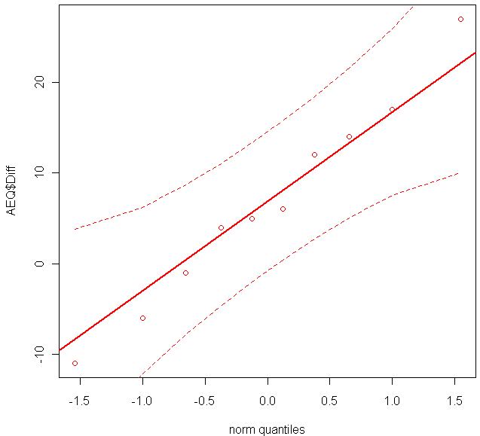
An intern in your consulting firm generated the following graphs and output (next page). Which graphs do you need to check your assumptions? Are the assumptions met?
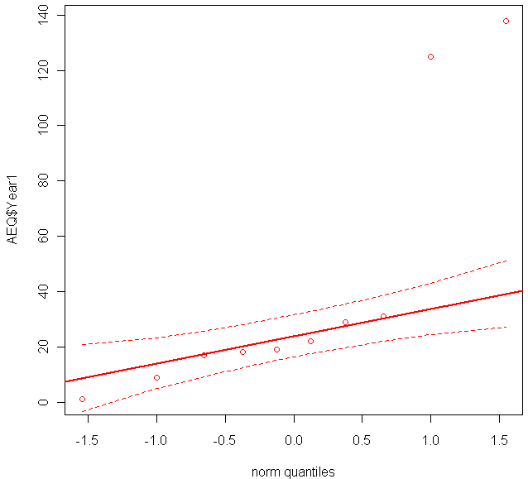
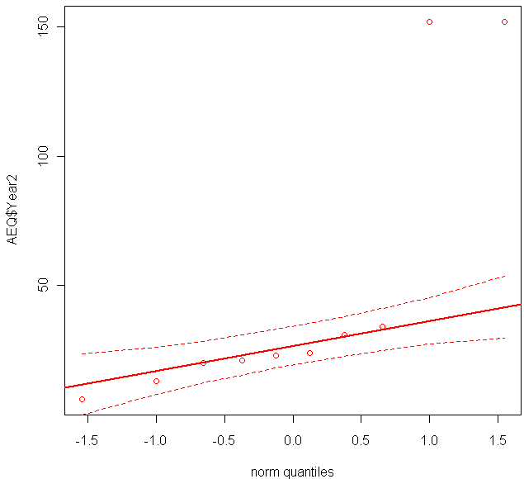
Year 1 Year 2 Diff=Year2-Year1

Welch Two Sample t-test Output 1
t = 0.2868, df = 17.687, p-value = 0.7776
alternative hypothesis: true difference in means is not equal to 0
95 percent confidence interval:
-42.43455 55.83455
sample estimates:
mean of x mean of y
47.6 40.9

Paired t-test Output 2
t = 1.8792, df = 9, p-value = 0.09293
alternative hypothesis: true difference in means is not equal to 0
95 percent confidence interval:
-1.365541 14.765541
sample estimates:
mean of the differences
6.7

Which t-test output should you use for your hypothesis test? Output 1 Output 2
Complete the hypothesis test procedure using your chosen output.

Test statistic:

Provide and sketch the distribution of test statistic assuming null is true:
(same as distribution used to find p-value)

P-value:

Based on our p-value compared to our significance level, we would Reject H₀ Not Reject H₀

What conclusion would you report to the EPA?

Would a 90% confidence interval for the parameter(s) defined in your hypotheses contain the value 0? How can you tell without computing the interval?

Interpret your p-value.

