Data Set 1: Endangered Species Listings (partial data set from U.S. Fish and Wildlife Service)
Animals only, and only endangered (not threatened) – Full data set at http://ecos.fws.gov/

- What types of graphs would be appropriate to display this data?
Group | United States | Foreign | Total
Mammals | 70 | 255 | 325
Corals | 0 | 0 | 0
Reptiles | 13 | 66 | 79
Amphibians | 14 | 8 | 22
Fishes | 74 | 11 | 85
Clams | 62 | 2 | 64
Snails | 24 | 1 | 25
Insects | 47 | 4 | 51
Arachnids | 12 | 0 | 12
Crustaceans | 19 | 0 | 19
Birds | 75 | 179 | 254
Total | 410 | 526 | 936

2. What percentage of all endangered species are birds?

3. What percentage of endangered amphibians species are endangered in the U.S.?

4. What percentage of endangered reptiles are endangered outside the U.S.?

5. Compare conditional distributions. Does the distribution of endangered species in the U.S. by group look to be the same as the Foreign distribution?

Simpson’s Paradox Example: Berkeley Discrimination Data
Overall: 44.28% males admitted, 34.58% females admitted with females being 33.86% of the applicants

Dept. | M. Admit. | M. Den. | M. Tot. | % M. Admit | F. Admit. | F. Den. | F. Tot. | % F. Admit.
A | 512 | 313 | 825 |  | 89 | 19 | 108
B | 313 | 207 | 560 |  | 17 | 8 | 25
C | 120 | 205 | 325 | 36.92 | 202 | 391 | 593 | 34.06
D | 138 | 279 | 417 | 33.09 | 131 | 244 | 375 | 34.93
E | 53 | 138 | 191 | 27.75 | 94 | 299 | 393 | 23.92
F | 22 | 351 | 373 | 5.90 | 24 | 317 | 341 | 7.04
Histogram Examples:

Example 1: Example 2:
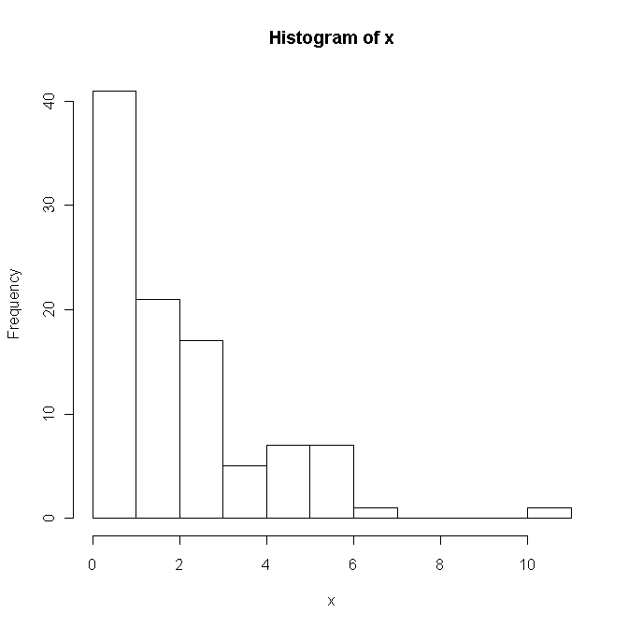
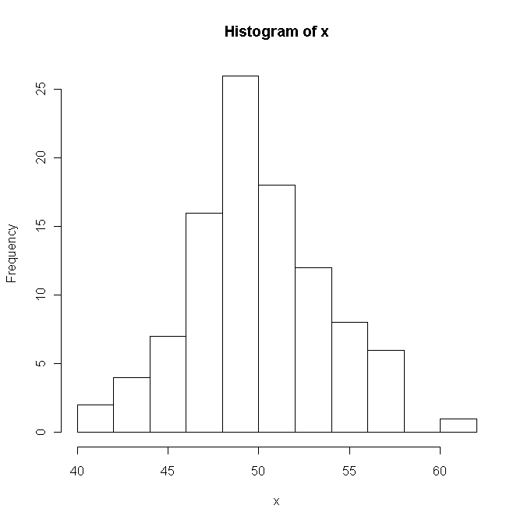

Example 3: Example 4:
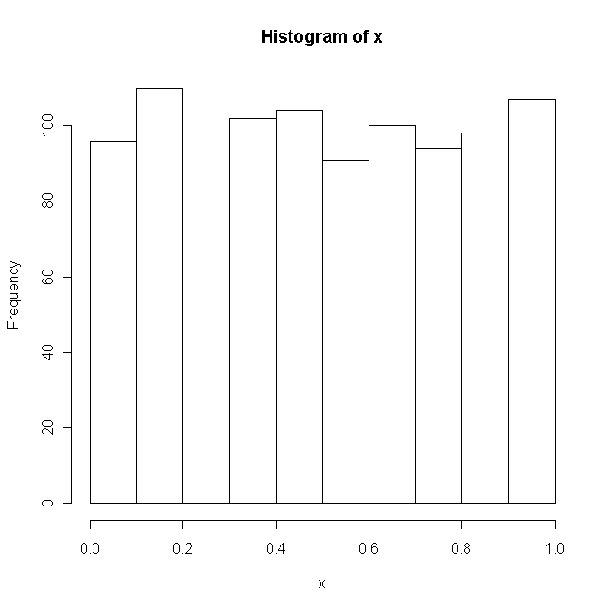
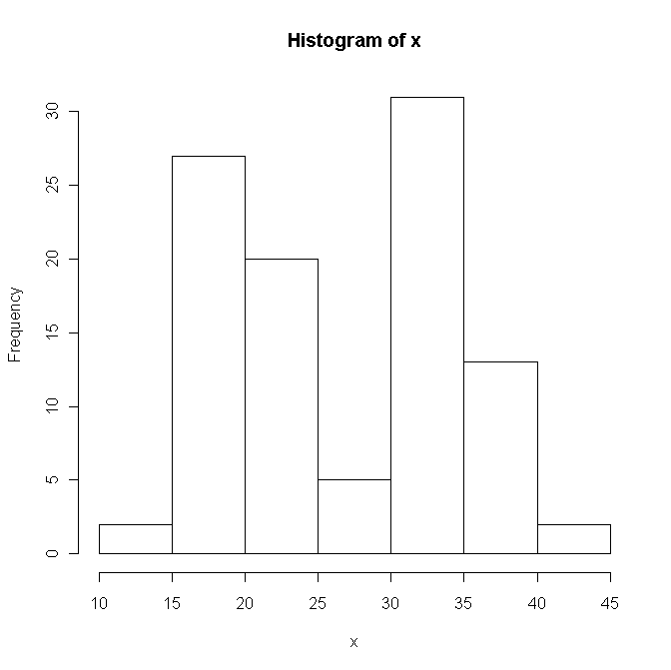

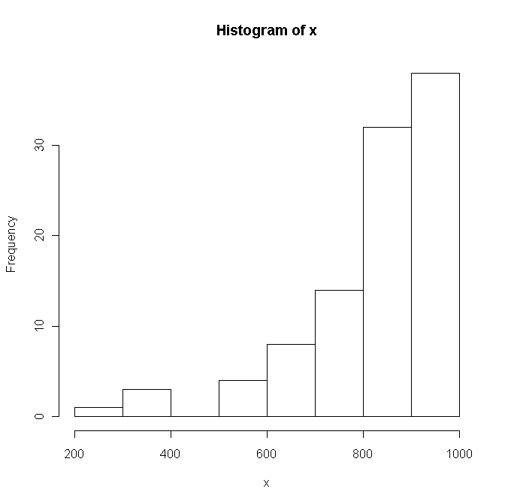
Example 5:
Data Set 2: Aluminum contamination in plastics (parts per million) (Devore and Peck)
26 observations

30, 30, 60, 63, 70, 79, 87, 90, 101, 102, 115, 118, 119, 119, 120, 125, 140, 145, 172, 182, 183, 191, 222, 244, 291, 511

Based on the sorted data listing, you’d expect the histogram to be ______________________________.

Ignore the 511 observation for a moment. How many bins do you want to use to display the rest of the data? What size would each bin be?

Prof. W. decided to use bin sizes of 30, which will be used to sketch the histogram. Sketch the histogram using bin sizes of 30. Include the 511 observation (there will be a gap in the histogram).

Data Set 3: Chemical amounts in drinking water

6 observations sampled during a particular month: 230, 180, 200, 270, 210, 170

Mean:

Median:

Range:
Q1:
Q3:

IQR:

Standard Deviation:

Obs (x) | $$x−\bar{x}$$ | $$(x−\bar{x})^{2}$$
170
180
200
210
230
270
Total

Example boxplot: Boxplot with outlier after changing 270:

Outlier computations:

