Hypothesis Test Example for a Population Mean (Based on related question in Moore)
An environmentalist group collects a liter of water from each of 40 locations along a stream and measures the amount of dissolved oxygen in each specimen (recorded in milligrams). Perform a hypothesis test to determine if the stream has a mean oxygen content of less than 5 milligrams per liter. (Note the R output provided may not give the direction you want for the alternative, but you CAN still get the correct p-value with a modification.)

Interpret your test statistic and p-value.
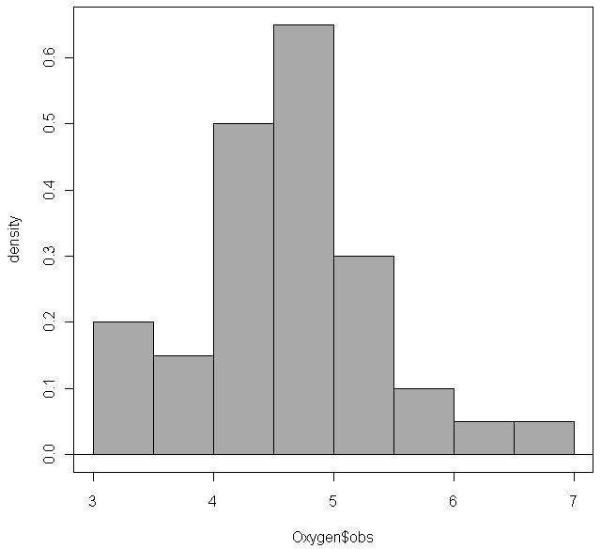
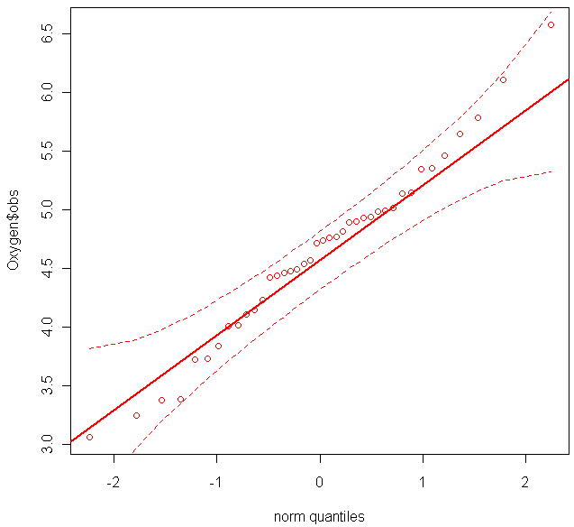
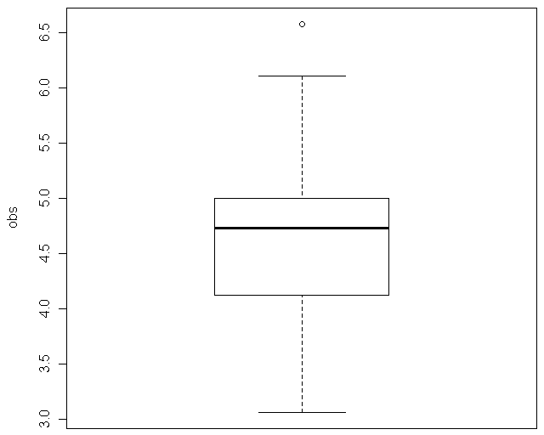
Oxygen
mean sd 0% 25% 50% 75% 100% n
4.633263 0.7641106 3.061219 4.137439 4.728889 4.999719 6.581082 40

t.test(Oxygen$obs, alternative='two.sided', mu=5.0, conf.level=.95)

One Sample t-test

data: Oxygen$obs
t = -3.0355, df = 39, p-value = 0.004263
alternative hypothesis: true mean is not equal to 5
95 percent confidence interval:
4.388889 4.877638
sample estimates:
mean of x
4.633263

