ANOVA Example

Researchers in 3 different cities decided to compare average pH of rainwater from their cities based on data collected over the past 6 months. Each researcher obtained a random sample of pHs for their city. Help the researchers determine whether their cities have the same or different average pH levels for rain. Preliminary analysis and formal analysis output is given below from Rcmdr. Note: pH = 7 is neutral. Values below 7 are acidic, and normal rainwater has a pH of 5.3, while acid rain is even lower.

Preliminary analysis:

mean sd 0% 25% 50% 75% 100% n
city1 5.164 0.1950910 4.68 5.0600 5.14 5.2800 5.75 40
city2 4.980 0.1369260 4.71 4.8875 4.95 5.0550 5.29 40
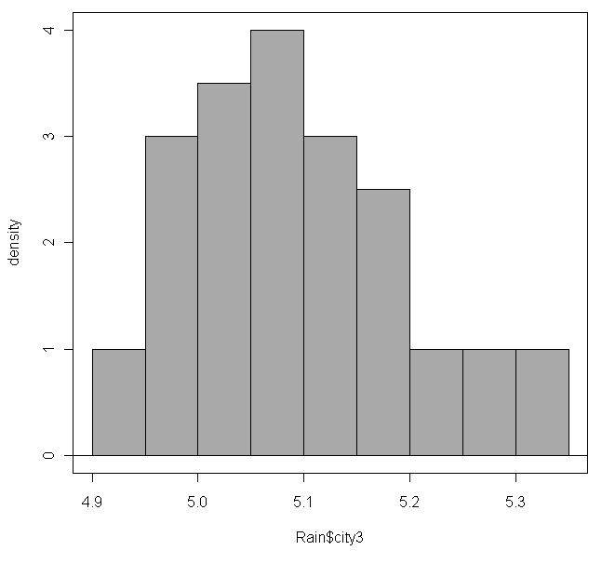
city3 5.100 0.1026570 4.90 5.0300 5.09 5.1625 5.32 40
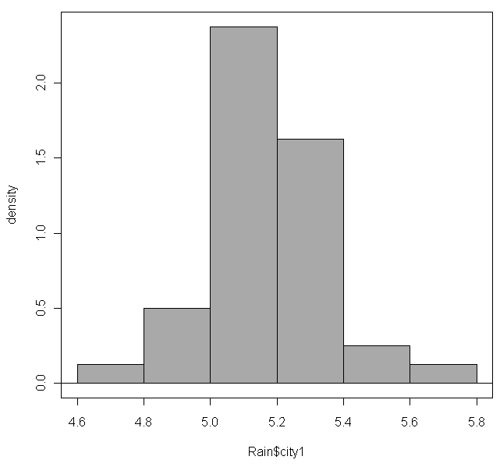
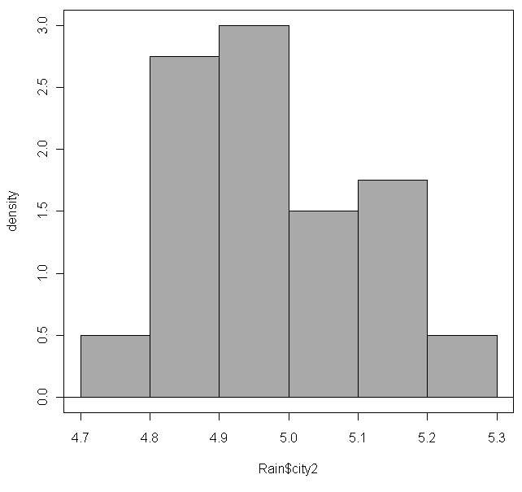
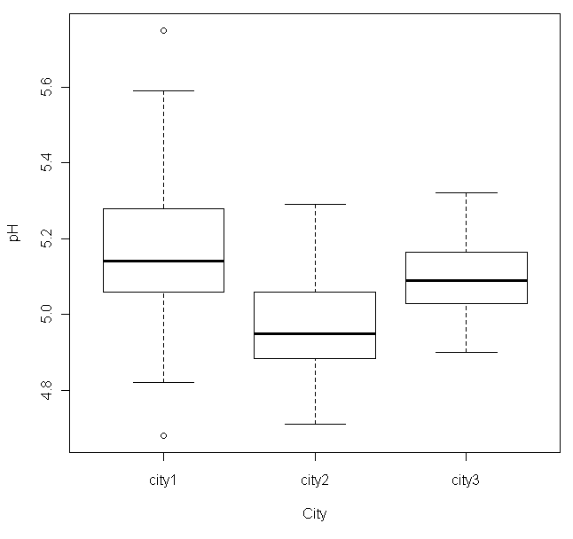
What does the preliminary analysis reveal to you?

What hypotheses should you test?

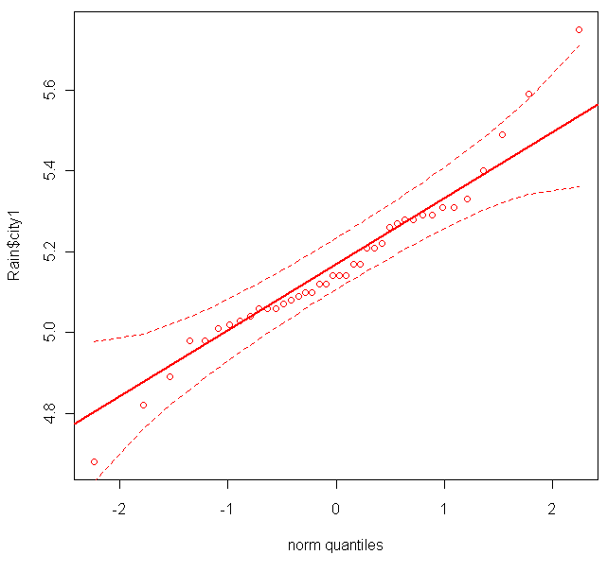
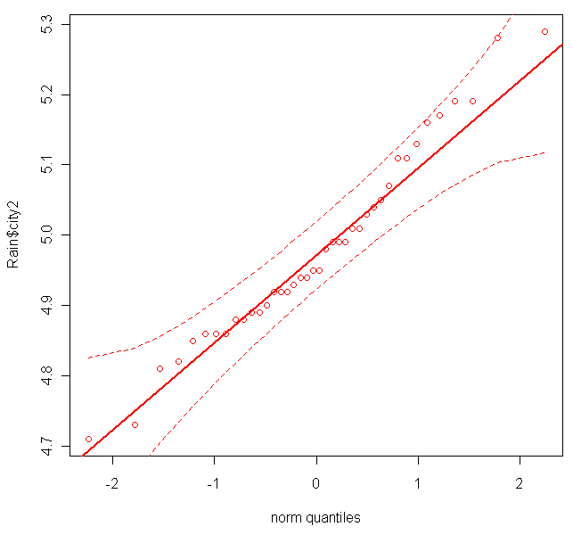
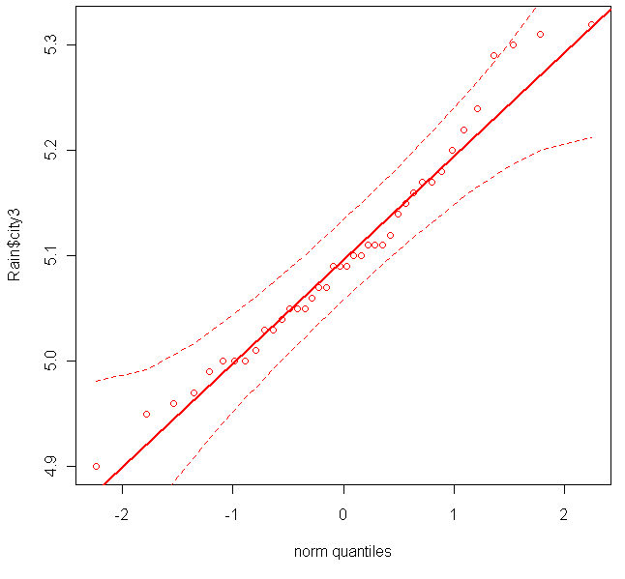
What assumptions need to be met? Do they appear to check out?

Use the selected Rcmdr output below to complete the test and multiple comparisons (if appropriate). Also, estimate the common population standard deviation.
AnovaModel.1 <- aov(pH ~ City, data=Rain2) Test Stat:
summary(AnovaModel.1)
Df Sum Sq Mean Sq F value Pr(>F) Dist of Test Stat:
City 2 0.69803 0.34901 15.547 1.029e-06 ***
Residuals 117 2.62656 0.02245 p-value:

Conclusion:
Multiple Comparisons of Means: Tukey Contrasts
95% family-wise confidence level
Linear Hypotheses:
Estimate lwr upr
city2 - city1 == 0 -0.18400 -0.26353 -0.10447
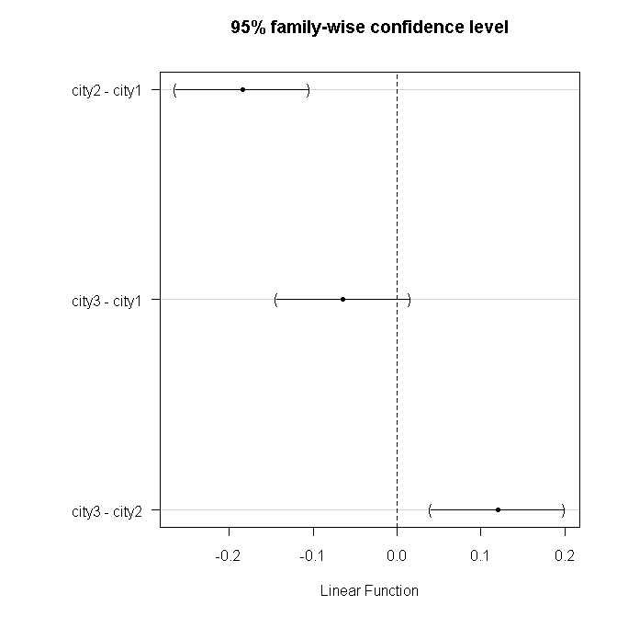
city3 - city1 == 0 -0.06400 -0.14353 0.01553
city3 - city2 == 0 0.12000 0.04047 0.19953

Multiple Comparisons (if appropriate):

