Mosquito Control and Prevention
Mosquitos are active from April – October

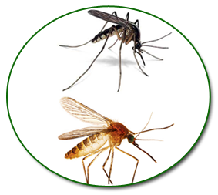
West Nile Virus (WNV) and Eastern Equine Encephalitis (EEE or “Triple E”) are viruses that can cause illness ranging from a mild fever to more serious disease like encephalitis or meningitis. These illnesses are spread to people through the bite of an infected mosquito.
- There are no specific treatments for either virus, so protect yourself from illness, by;
  - Scheduling outdoor activities before dusk and after dawn
    - Avoid areas wear standing/stagnant water is present
      - Eliminate breeding areas with stagnant water (during the day) from flower pots, buckets, barrels, small pools and other containers
    - Avoid wooded and tall grass areas
  - Wearing long sleeve shirts and full length pants
    - Light colored clothing is best
  - Use the following appropriate insect repellents with DEET, Picaridin, IR3535 or Oil of Lemon Eucalyptus
    - Spray clothes and skin
    - Use wipes (not spray) on and around the ears and face
  - Making sure window screens (without damage) are in place

